|  |  |
| --- | --- |
| logo_rvb | The CAMECA IMS 7f-Auto  Tuning user’s guide  00 45 627 958 – Type 108 – Indice A |

[Index](D:\\Notices\\3.1.8\\7f_4fe7_index.doc)

Contents

[1. The Tuning Principles 3](#_Toc348617472)

[1.1 The Instrument Status File (ISF), MAP and OIP 3](#_Toc348617473)

[1.2 The interface principles: Synoptics and Presets 4](#_Toc348617474)

[1.3 The Hardware: Real time screen and dedicated keyboard 5](#_Toc348617475)

[1.4 The Tuning software options 6](#_Toc348617476)

[2. The Tuning Panels Description 7](#_Toc348617477)

[2.1 The main menu bar 7](#_Toc348617478)

[2.2 The Setup box 8](#_Toc348617479)

[2.3 Loading and saving an ISF 9](#_Toc348617480)

[2.4 The synoptic panel 10](#_Toc348617481)

[2.5 The preset boxes (1): The standard preset box 12](#_Toc348617482)

[2.6 The preset boxes (2): Apertures and Mass 14](#_Toc348617483)

[2.6.1 Mass functions 14](#_Toc348617484)

[2.6.2 Center Mass routine 16](#_Toc348617485)

[2.6.3 Aperture functions 17](#_Toc348617486)

[2.6.4 Contrast Aperture automated Centering routine 18](#_Toc348617487)

[2.6.5 Entrance Slit automated Centering routine 18](#_Toc348617488)

[2.6.6 Energy Slit automated Adjust routine 19](#_Toc348617489)

[2.6.7 The Mass Resolution presets 22](#_Toc348617490)

[2.7 The preset boxes (3): The detector box. 23](#_Toc348617491)

[2.7.1 EM Centering automated routine 24](#_Toc348617492)

[2.7.2 FC Centering automated routine 25](#_Toc348617493)

[2.7.3 EM Adjust automated routine 25](#_Toc348617494)

[2.7.4 FC Adjust automated routine 25](#_Toc348617495)

[2.8 Center Secondary automated routine 26](#_Toc348617496)

[2.9 The "Beam Position" and "Area Position" boxes 27](#_Toc348617497)

[2.10 The OIP Panel 28](#_Toc348617498)

[3. The ion source control 29](#_Toc348617499)

[3.1 The Cs Source control 29](#_Toc348617500)

[3.1.1 Overview 29](#_Toc348617501)

[3.1.2 The Cs source Start Process 29](#_Toc348617502)

[3.1.3 The Cs source Stop Process 30](#_Toc348617503)

[3.1.4 The Cs source Start/Stop panel 32](#_Toc348617504)

[3.1.5 The Cs source set-up parameter panel 34](#_Toc348617505)

[3.1.6 The Cs source links with the Setup file 37](#_Toc348617506)

[3.2 The Duo Source control 37](#_Toc348617507)

[3.2.1 Overview 37](#_Toc348617508)

[3.2.2 The Duo source Start Process 37](#_Toc348617509)

[3.2.3 The Duo source Stop Process 38](#_Toc348617510)

[3.2.4 The Duo source Start/Stop panel 38](#_Toc348617511)

[3.2.5 The Duo source set-up parameter panel 40](#_Toc348617512)

[3.2.6 The Duo source links with the Setup file 41](#_Toc348617513)

[3.3 The E-GUN Source Control 41](#_Toc348617514)

[3.3.1 Overview 41](#_Toc348617515)

[3.3.2 The E-GUN Start Process 41](#_Toc348617516)

[3.3.3 The E-GUN Stop Process 42](#_Toc348617517)

[3.3.4 The E-GUN Start/Stop panel 42](#_Toc348617518)

[3.3.5 The E-GUN set-up parameter panel 43](#_Toc348617519)

[3.3.6 The E-gun source links with the Setup file 43](#_Toc348617520)

[4. The Tuning Reference guide 43](#_Toc348617521)

[4.1 The ISF parameters list 43](#_Toc348617522)

[4.1.1 The source parameters 43](#_Toc348617523)

[4.1.2 The primary parameters 44](#_Toc348617524)

[4.1.3 The secondary parameters 45](#_Toc348617525)

[4.1.4 The NEG (E-Gun) Parameters 46](#_Toc348617526)

[4.1.5 Imaging Parameters 46](#_Toc348617527)

[4.2 The Synoptics Reference Guide 47](#_Toc348617528)

[4.2.1 Sources 47](#_Toc348617529)

[4.2.2 Primary column 48](#_Toc348617530)

[4.2.3 Secondary 48](#_Toc348617531)

[4.2.4 Egun 49](#_Toc348617532)

[4.2.5 RAE 50](#_Toc348617533)

[4.2.6 Apertures 50](#_Toc348617534)

[4.2.7 Imaging 50](#_Toc348617535)

[4.3 The Preset Reference Guide 51](#_Toc348617536)

[4.3.1 Primary beam, Ion beam ON/OFF, Beam Pos 51](#_Toc348617537)

[4.3.2 Maximum area 52](#_Toc348617538)

[4.3.3 Raster, Raster ON/OFF 52](#_Toc348617539)

[4.3.4 DTOS ON/OFF 53](#_Toc348617540)

[4.3.5 Electronic gate, e-gate ON/OFF 54](#_Toc348617541)

[4.3.6 Presets MCP\_Image et MCP\_Slit, FC et EM 54](#_Toc348617542)

[4.3.6.1 MCP\_Image et MCP\_Slit Presets 54](#_Toc348617543)

[4.3.6.2 FC and EM Presets 56](#_Toc348617544)

[4.3.7 E-GUN ON/OFF 56](#_Toc348617545)

[4.3.8 Motorized Aperture presets (Optional) 57](#_Toc348617546)

[4.3.8.1 Entrance slit 57](#_Toc348617547)

[4.3.8.2 Contrast Aperture 57](#_Toc348617548)

[4.3.8.3 Field Aperture 58](#_Toc348617549)

[4.3.8.4 Energy slit 58](#_Toc348617550)

[4.3.8.5 Exit Slit 59](#_Toc348617551)

[4.3.8.6 Mass resolution 59](#_Toc348617552)

[4.3.9 The Raster Linearity Correction 60](#_Toc348617553)

[4.3.9.1 Overview 60](#_Toc348617554)

[4.3.9.2 The Raster linearity correction box 63](#_Toc348617555)

[4.4 The indexation reference guide 64](#_Toc348617556)

[4.4.1 Valid + Source Accel HV 64](#_Toc348617557)

[4.4.2 Valid + Sample HV 65](#_Toc348617558)

[Contents ↑](#Contents)

# The Tuning Principles

## The Instrument Status File (ISF), MAP and OIP

The IMS 7f-Auto is fully computer controlled. All the instrument parameters are contained either in the *Set-up file* or in the *Instrument Status File* (ISF), except the magnet setting, or in other words the mass selection.

The *Set-up file* does not contain only instrument parameters; it contains also a lot of software routine parameters (e.g. the threshold from switching from EM to FC in an analysis). Instrument parameters which are contained in the *Set-up* file are those which do not depend on the MAP, either they are expected to be fix all along the instrument life (e.g. the MCP phosphorus screen voltage) or there depend only on a consumable device aging (e.g. the EM voltage or the Cs source reservoir current). Some *Setup file* parameters can be read and edited from the *Tuning* interface or from the *Tool* interface. All the *Setup file* parameters can be read and edited from the *Setup file* viewer. Refer to the [*Setup file* user's guide](file:///D:\Notices\3.1.8\Software_users_guide-setup-list.doc).

An *Instrument Status File* (ISF) contains the set of the instrument settings corresponding to a required physical configuration. This required physical configuration determines a set of *Main Analytical Parameters* (MAP). See below the list of MAP. An ISF does not correspond to a single instrument configuration. The selections which can be done within a given ISF (e.g. the primary raster size, or the exit slit width) are called *Optional Instrument Parameters* (OIP).

In this document, *Preset* and OIP have very similar meanings. Generally, each preset or OIP consists of several parameters. The principle is to constitute a reduced set of selection for simplifying the way of operating the instrument.

**MAP list**

* The nature of primary ions (Cs+/O2+/O-)
* The primary source location (30°col)
* The primary accelerating voltage (e.g. 10kV)
* The impact energy (e.g. 5 keV)
* The secondary ion polarity (+/-)
* The secondary ion accelerating voltage (e.g. 5 kV)

**OIP list**

With the *Tuning* interface, all the presets can be selected separately from the main *Tuning* menu bar. See below the sections § [The main menu bar](#_The_main_menu), § [The preset boxes (1)](#_The_preset_boxes), § [The preset boxes (2)](#_The_preset_boxes_1) and § [The preset boxes (3)](#_The_preset_boxes_2). An overall configuration can also saved and restored from the OIP Panel. See below the section § [the OIP panel](#_The_OIP_Panel).

It is explained in the [*Analysis software user's guide*](file:///D:\Notices\3.1.8\Software_users_guide-analyses.doc) that a set of OIP must be defined for each analysis. These OIPs will be automatically loaded at the beginning of an analysis.

| **OIP** | **Way of use in *Tuning*** | **Way of use in *Analysis*** |
| --- | --- | --- |
| Primary beam (1/2/.../9) | § [Primary Beam](#_Primary_beam,_Ion) | selectable |
| Max Area (1/2/.../9) | § [Max Area](#_Maximum_area) | selectable |
| Raster (µm) | § [Raster](#_Raster,_Raster_ON/OFF)  Discrete selection (1/2.../9) in the *Preset pad*. Editable in the OIP box. | editable in µm |
| DT (ON/OFF) | § [DT ON/OFF](#_DTOS_ON/OFF) | ON/OFF |
| E-Gate (%) | § [E-gate](#_Electronic_gate,_e-gate)  Discrete selection (1/2.../9) in the *Preset pad*. Editable in the OIP box. | editable in % |
| Detector (Slit/Ima/FC/EM) | § [detector presets](#_Presets_MCP_Image_et) | FC or EM are defined for each analyzed mass. |
| Slit and Image zoom | § [detector presets](#_Presets_MCP_Image_et) | N/A |
| Entrance Slit (µm) | § [Motorized apertures](#_Motorized_Aperture_presets)  Discrete selection in the OIP box. | editable in µm |
| Energy Slit (eV) | § [Motorized apertures](#_Motorized_Aperture_presets)  Discrete selection in the OIP box. | editable in both position (eV) and width (eV) |
| Exit Slit (MR) | § [Motorized apertures](#_Motorized_Aperture_presets)  Discrete selection in the OIP box. | editable in MR |
| Contrast Aperture (1/2/3/4) | § [Motorized apertures](#_Motorized_Aperture_presets) | selectable |
| Field Aperture (1/2/3/4) | § [Motorized apertures](#_Motorized_Aperture_presets) | selectable |
| Mass resolution | § [Motorized apertures](#_Motorized_Aperture_presets)  Selectable as a preset consists of CA, FA apertures and Ent, Ener, Exit slits on the OIP box. | If it is manually edited, this will replace the selection of the Exit Slit. |

[Contents ↑](#Contents)

## The interface principles: Synoptics and Presets

* It is possible to assign the 3 [*dedicated keyboard*](#_The_Hardware:_Real) thumbwheels to a set of 3 parameters either with the synoptic box or with the different preset boxes.
* The parameter current values activated by the keyboard thumbwheels are displayed in the [*Real Time Screen*](#_The_Hardware:_Real)*.*
* Most of the ISF parameter controlling directly the instrument is available from the synoptic panel.
* In each preset box, only the parameters included in the considered preset are available. This box is purposed for building the preset.

## The Hardware: Real time screen and dedicated keyboard

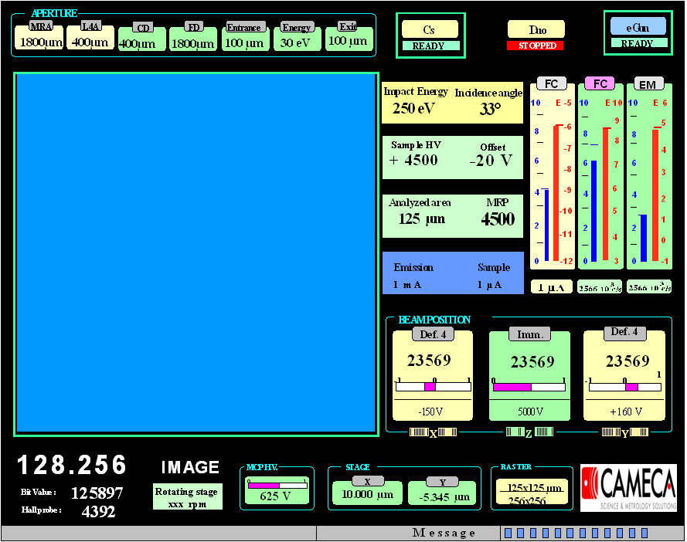

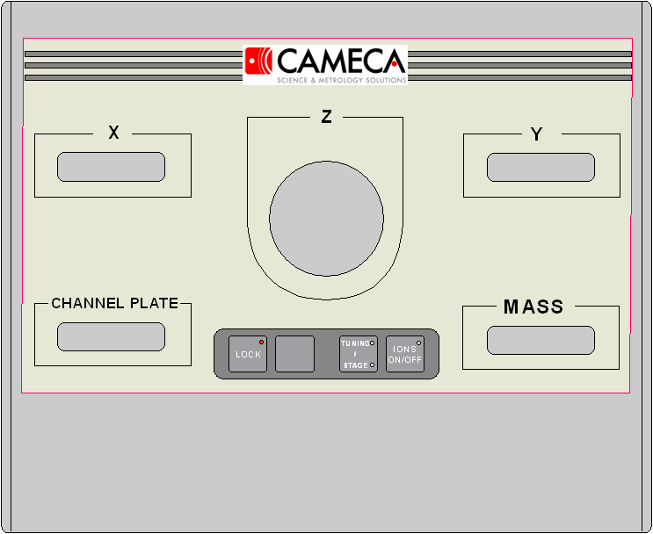

[Contents ↑](#Contents)

## The Tuning software options

Path: Tuning (Main menu bar + Setup + Options)

|  |  |
| --- | --- |
|  | For IMS7f Auto, select   * 7F Auto   Select also, if the accessories are implemented on the instrument   * Duo Accel-decel * EM Post-Acceleration * RAE |

[Contents ↑](#Contents)

# The Tuning Panels Description

## The main menu bar

|  |  |
| --- | --- |
|  | **File** displays the selection menu *open/save/save as/Change linearity/Print/Print Setup*. Refer below to the section § [Loading and saving an ISF](#_Loading_and_saving_1)  **Setup** displays the selection menu [*Sources*](#_The_ion_source_control)*/Calib Cs Position/*[*Work with*](#_The_ion_source) */*[*options*](#_The_Tuning_software_options) */*[*parameters*](#_The_Setup_box)  **View** displays the menu *Tool bar/Status*. See below.  opens the [ISF loading box](#load_box).  saves the current instrument configuration with the displayed filename. Refer to the section § [Loading and saving an ISF](#_Loading_and_saving_1).  opens the [Synoptic panel](#_The_synoptic_panel).  opens the [OIP panel](#_The_OIP_Panel_1).  opens the [Start/Stop Cs source panel](#_The_Start/Stop_CS) or the [Start/Stop Duo panel](#_The_Duo_source)  refreshes the link between the workstation and the MicroProcessor.  displays the current ISF label .  opens the [Mass and aperture box](#_The_preset_boxes_2).  displays the current ***Primary beam*** preset label. Clicking the button switches the primary beam ON/OFF (equivalent to the dedicated keyboard button). ⮛ opens the [Primary beam preset box](#_The_preset_boxes).  opens the [Beam Position box](#_The_OIP_Panel)  displays the current ***Raster size*** preset label. Clicking the button switches the Raster ON/OFF. ⮛ opens the [Raster preset box](#_The_preset_boxes).  displays the current ***Max Area*** preset label. ⮛ opens the [Max Area preset box](#_The_preset_boxes).  **Area Pos** opens the [Area Position box](#_The_OIP_Panel).  **DTOS OFF/ON** switches the dynamic transfer DT ON/OFF. ⮛ opens the [DTOS preset box](#_The_preset_boxes).  switching the eGate ON/OFF. If eGate=ON, the field displays the eGate ratio (%). ⮛ opens the [eGate preset box](#_The_preset_boxes).  **Image/Slit/EM/FC/Image RAE** selects the [detector preset](#_The_preset_boxes_1). Both the *Image* and *Slit* fields display also the given zoom preset. ⮛ opens the [detector preset box](#_The_preset_boxes_1).  opens the [Center Secondary box](#_Center_Secondary_automated).  **N.E.G**  switches the [NEG ON/OFF](#_E-GUN_preset). |

**View/***Tool bar* allows to display or to suppress the icon bar 

**View/***Status* allows to display or to suppress the bottom line. 

## The Setup box

Path: Tuning (Main menu bar + Setup + Parameters)

This panel allows to edit some parameters which will be registered in the setup file when saving the ISF

|  |  |
| --- | --- |
|  | **Secu Threshold and Hysteresis**:  These parameters control the EM/FC switching conditions along an analysis according to [the secondary ion optics user's guide/EM-FC switching](file:///D:\Notices\3.1.8\ion_optics_sec.doc#hyste)  If ***Enable EM Soft Security***is notched, the detector switches automatically from EM to FC in the same conditions as with an analysis.  **FC offsets** are the secondary Faraday Cup background level. See also user’s guide ***Scan all***.  **Primary Current offsets** are targeted to take into account that [primary FC offsets in the sampling mode](file:///D:\Notices\3.1.8\ion_optics_prim.doc#FCp) may be different from the static mode. This is due to some electrical leakage problems that can be pointed out by a residual value when the static offset is correctly compensated (Refer to the user’s guide ***Scan all***) and when the ion source is set off. Enter this residual into the corresponding editing field. |

**Soft threshold and FCs Offset Setup parameters**

|  |  |  |
| --- | --- | --- |
| # | **Set-up Label** | **Comments** |
| 414 | THR\_SECU\_SOFT\_VAL | Refer to the [second ion optics user's guide/ detectors](file:///D:\Notices\3.1.8\ion_optics_sec.doc#hyste) |
| 387 | FCs Offset (pos. polarity) | Refer to the [second ion optics user's guide/ Faraday](file:///D:\Notices\3.1.8\ion_optics_sec.doc#FCs) |
| 607 | FCs Offset (neg polarity) | Refer to the [second ion optics user's guide/ Faraday](file:///D:\Notices\3.1.8\ion_optics_sec.doc#FCs) |

## Loading and saving an ISF

It is possible to load an ISF either by clicking the icon  or by selecting the menu *File/Open*.

|  |  |
| --- | --- |
|  | * **Open** opens the [ISF loading box](#load_box). * **Save** saves the Instrument settings under the current filename displayed at the top of the *Tuning* menu bar. It saves also the Setup parameters in the *setup file*. * **Save as** opens the ISF saving box for saving the instrument setting under a new file name. It saves also the Setup parameters in the *setup file*. * **Change Linearity** copies linearity coefficients from current ISF file to other ISF files without loading. * **Print** prints the ASCII ISF. * **Print Setup** allows to set the printer configuration. |

When saving a file, the suffix C6/D6 is added to the filename according as the source selection: Cs/Duo. The source selection can be done either by loading an ISF of the required type - that is the normal way - or by selecting the source with *Setup/Work with* (*Tuning* bar top), that must be done only the first time a new type ISF is created for the instrument.

**The ISF loading box**

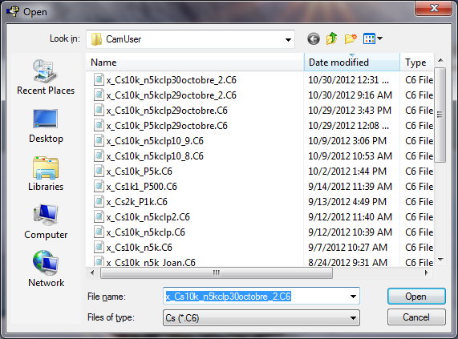

Select the required ISF and click *Open* for loading the ISF.

The field *Files of type* allows to sort the ISF according to their suffix C6/D6 which corresponds to the ion source location (Cs/Duo).

Loading an ISF loads also the instrument setting contained in the *Setup file.*

**Saving and loading Setup parameters**

|  |  |  |
| --- | --- | --- |
| # | **Set-up Label** | **Comments** |
| 718 | Working filename | *Tuning/Open* |
| 719 | Default ISF Folder | *Tuning/Open* |

[Contents ↑](#Contents)

## The synoptic panel

Clicking the icon  in the top of the *Tuning* menu bar  opens the *synoptic panel* displayed below.

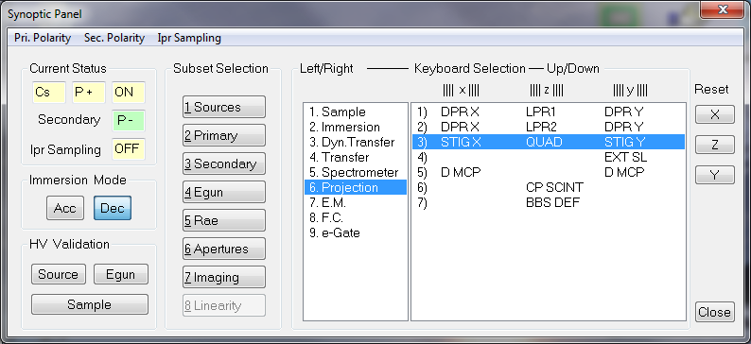

For assigning a given parameter to a *dedicated keyboard* thumbwheel, it is necessary to follow a path, e.g. *3.Secondary / 6.Projection / 3)* for assigning the kbd thumbwheels to

(STIGX, QUAD, STIGY)

*Secondary*, *Projection* and *3)* are selected on the right hand side of the box. Refer to the section § [The Synoptics Reference Guide](#_The_Synoptics_Reference) for the overall classification of all the parameters available with the synoptic panel.

**Polarities** allow to switch the primary polarity and the secondary polarity,

**Current status** displays the current source status.

**Ipr Sampling** shows the status of the primary ion beam sampling *ON/OFF*

**Acc/Dec IMM** allows to switch the immersion lens mode from accel to decel.

**Valid Source HV** opens the *Valid Source HV Box*. (See below)

**Valid Sample HV** opens the *Valid Sample HV Box*. (See below)

**Valid Egun HV** opens the *Valid Egun HV Box*. (See below)

**Reset X, Y, Z** allow to reset all parameters on a selected axis to zero.

**The *Valid Accel HV* and the *Valid Sample HV* boxes**

|  |  |
| --- | --- |
|  |  |
| Valid *Accel HV* is purposed to transform an ISF tuned for a given Accel HV (Old Value) to an ISF suited for a new *Accel HV* (New Value).   * Load the old ISF onto the instrument. * Assign the kbd thumbwheel to *Accel HV* by selecting S*ynoptic/Primary/ Sources*. * Set the *Accel HV* to the required value (Caution, if the Cs Source is used, it is necessary to tune the heating currents for Ionizer and Reservoir by hand) * Open the *Valid Accel HV* box in the synoptic panel. * The previous *Accel HV* is then displayed in the *Old Value* field while the new value is displayed in the *New value* field * Click *Valid*. * The overall primary settings are transformed according to the section § [*The indexation reference guide*](#_The_indexation_reference)*.* * Tune the primary *last lens (LPRIM4)* and *Beam Pos X&Y.* * Save the new ISF with a new name.   ***Note***; if the old value displays zero, Click *Reset* in order to read the current status first as a reference before varying *Accel HV*.  Refer to the Primary ion optics user's guide. | Valid *Sample HV* is purposed to transform an ISF tuned for a given Sample HV (Old Value) to an ISF suited for a new *Sample HV* (New Value).   * Load the old ISF onto the instrument. * Assign the kbd thumbwheel to *Sample HV* by selecting S*ynoptic/Secondary/ Sample*. * Set the *Sample HV* to the required value. * Open the *Valid Sample HV* box in the synoptic panel. * The previous *Sample HV* is then displayed in the *Old Value* field while the new value is displayed in the *New value* field. * Click *Valid*. * The overall primary settings are transformed according to the section § [*The indexation reference guide*](#_The_indexation_reference)*.* * Tune the primary *last lens(LPRIM4)* and *Beam Pos X&Y.* * Save the new ISF with a new name.   ***Note***; if the old value displays zero, Click *Reset* in order to read the current status first as a reference before varying *Sample HV*.  Refer to the Secondary ion optics user's guide. |

[Contents ↑](#Contents)

## The preset boxes (1): The standard preset box

The "Standard preset box" can be opened by clicking ⮛ associated either to the button *Primary beam* or *Raster* or *eGate* or *Max Area* or *DTOS*.

The "Standard preset box" consists of the *Preset pad*, at the left hand side, and the *Calib* box, at the right hand side, which must be opened only for modifying the content of a preset.

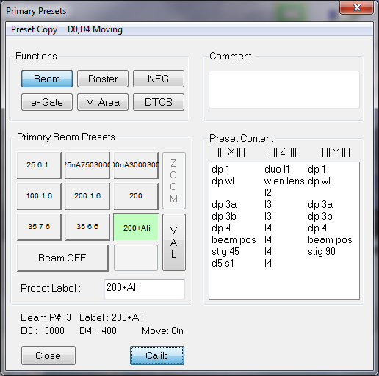

* The buttons ***Beam***, ***Raster, NEG, e-Gate***, ***Max Area*** and ***DTOS*** allows to select the required preset pad.
* **Preset Copy** is purposed for copying the current settings to any preset number; it displays the selecting menu 1/2/3.../9, corresponding to the following positions on the keypad.

|  |  |  |
| --- | --- | --- |
| 7 | 8 | 9 |
| 4 | 5 | 6 |
| 1 | 2 | 3 |

The current settings will be memorized in the selected preset number.

* **Preset label** edits the preset name. Valid the label with the computer keyboard *Enter.*
* **D0, D4 Moving** with Beam Presets is purposed to select the movement of D0, D4 apertures or not when a preset is selected.

***Note*** *that it is recommended to keep* ***ON*** *in order to correctly set a desired primary current and column alignment which are* [*inseparably linked with*](http://endic.naver.com/enkrIdiom.nhn?idiomId=304434fbc4ea4271bc8511c1fb4723f3) *the combination of D0, D4 apertures.*

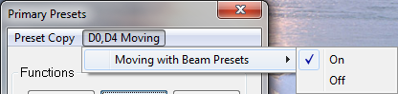

* The selection of D0, D4 apertures ise included to each preset settings when a preset is validated. This information is shown at the lower part of the preset panel when the cursor is placed on a preset.

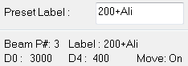

* **Valid** is enabled if *Calib* has been clicked. It modifies the preset content.
* **Calib** opens or closes the right hand side *calib box.*
* The **Calib box** allows to assign the kbd thumbwheels to a selected line in order to modify a preset. The preset will not be actually modified if the *calib box* is closed without having clicked *Valid*.
* **Close** closes the box.

For the rules specific to each preset pad (i.e. the *Max Area* preset labels must be numerical, *Valid+Raster* has an effect onto all the presets ...), refer to the section § [The Preset Reference Guide](#_The_Preset_Reference).

[Contents ↑](#Contents)

## The preset boxes (2): Apertures and Mass

### Mass functions

|  |  |
| --- | --- |
|  | **Calib**  **Direct Calib** adds the line (M, B) to the current [M, B] table.  **Shift Mass** shifts all the [M, B] table according to the ratio (M1/M2) by modifying the Mass in the [B, k(B)] table (Refer to the [secondary ion optics guide](file:///D:\Notices\3.1.8\ion%20optics%20sec.doc) for information about the [B, k(B)] table)  **Call Calib** opens the Mass calibration routine.  **Tools**  **Aperture init** opens the *Aperture Init box* (See below)  **Sample offset** opens the *Sample HV offset* *box* (See below)  **Clear Energy Slit X offset** resets the Energy Slit X to zero for all energy slit presets.  **Mass**  **Mass Centering** opens the ***Scan All***dialog box. The magnetic field is scanned around the initial value. (See [§ Center Mass Routine](#_Center_Mass_routine)).  **Clear List of mass** removes recently called masses on a scroll down list of Set Mass box.  **Set Mass** edits the required mass, validated by the computer kbd *Enter* or by clicking *Apply.*  **button** is the same function as Mass Centering (See [§ Center Mass Routine](#_Center_Mass_routine)).  **Apply** loads the edited mass to the instrument.  increments the mass of +/- 1 amu. |

**The Aperture Init box**

Can be opened from the *Aperture and Mass Box*. Select *Tools/Aperture Init.*

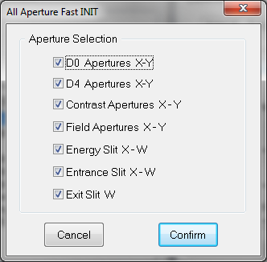

***Note*** *that this aperture initialization needs to be performed when the instrument is newly started i.e. after a reset instrument electronics, an aperture supply switch off etc.*

**The Sample HV offset box**

Can be opened from the *Aperture and Mass Box*. Select *Tools/Sample Offset.*

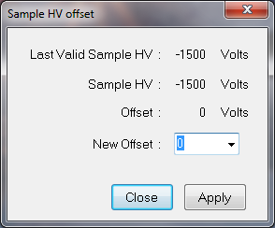

***Note*** *that this sample HV offset is also available on the Mass & Apertures panel without opening this box.*

[Contents ↑](#Contents)

### Center Mass routine

After clicking on the *Center mass* button, the following routine is automatically performed:

* ***Scan all*** dialog box is opened.
* The magnetic field is scanned around the initial value by using following parameters; B field Range = digits corresponds to 4ΔM, Step = 40, Wait time = Count. Time = 0.08 sec,
* EM will be used for the scanning if Image/Slit/EM or RAE detectors have been selected at the beginning of the scan routine. If there is a switching between EM and FC during the scanning, the scanning stops then start again using FC detector. This second full scanning will be used for the centering.
* FC will be used for the scanning if FC has been selected at the beginning of the scan routine.
* The centering is determined at 50% after the scan is completed.
* The final magnetic field obtained after centering is applied to the machine.

***Note*** *that the mass calibration table is not modified, unless* ***Direct Calib*** *or* ***Shift Mass*** *functions are used.*

[Contents ↑](#Contents)

### Aperture functions

These presets control directly the instrument. Before starting an analysis, it is advisable to select the presets corresponding to the status of the instrument, since this information is stored in the data files.

|  |  |
| --- | --- |
|  | **D0** allows to assign the *aperture preset pad* to select the first primary aperture.  **D4** allows to assign the *aperture preset pad* to select the second primary aperture.  **CA/FA/Ent/Ener/Exit** allows to assign the *aperture preset pad* to the selected aperture :   * CA stands for *Contrast Aperture*. * FA stands for *Field Aperture*. * Ent stands for *Entrance slit*. * Ener stands for *Energy slit*. * Exit stands for *Exit slit*.   For the specific rule for each aperture, refer to the section § [Motorized aperture presets](#_Motorized_Aperture_presets). For example, it is explained that the *Exit Slit* and the *Entrance slit* presets cannot be changed, that *Exit Slit* is expressed as a MR (Mass resolution) while *Entrance Slit* is expressed in µm.  For any selection of D0/D4/CA/FA apertures and Ent/Ener/Exit slits, **Calib** does not open the *Calib box* but assigns the kbd thumbwheels to the selected aperture axis.  **Valid** modifies the preset content, if the *Valid* is enabled, that is the case for D0, D4, CA, FA and Ener.  By clicking the  button opens the **Mass Resolution preset** *box* on the right hand side. (See below)  button is available at the bottom of the preset panel in case of [*Contrast Aperture (CA)*](#_Contrast_Aperture_automated) and [*Entrance slit (Ent)*](#_Entrance_Slit_automated). **Center** launches automatic centering procedure by ***Scan All*** program. (See below)  button is available at the bottom of the preset panel only for [*Energy slit (Ener)*](#_Energy_Slit_automated). **Adjust** launches automatic adjust procedure by ***Scan All*** program (See below) |

**Remark 1**: The 3 slits labels cannot be entered since they are determined automatically from the actual aperture position. The *Exit Slit* label is in MR, the *Entrance slit* label is in µm and the *Energy Slit* in eV. If the labels are observed to be wrong, the expert operator must check the slit offset (in the Interface window, select the utility menu "Aperture and Stage", and there it is possible to select *Entrance width offset*/ *Exit width offset*/ *Energy width offset*/ *Energy slit position*). These functions must be activated after the operator has set respectively the Entrance width, the Exit width and the Energy width to zero or the low energy edge to axis.

**Remark 2** After an aperture supply switch off, the aperture positions taken into account by the instrument and displayed in the user’s interfaces are no more correct. It is necessary to activate *Init procedures* with the [*Aperture Init box.*](#_The_preset_boxes_2)

[Contents ↑](#Contents)

### Contrast Aperture automated Centering routine

After clicking on the *Center* button on the Contrast Aperture Presets panel, the following routine is automatically performed:

* The ***Scan All*** dialog boxis opened
* Both *Entrance Slit* and *Exit Slit* are completely opened.
* The secondary ion intensity is collected by scanning *CA X*: Range = 3000 (digits) for all ISF files, Steps = 20, Wait time = Count. Time = 0.08 sec,
* EM will be used for the scanning if Image/Slit/EM or RAE detectors have been selected at the beginning of the scan routine. If there is a switching between EM and FC during the scanning, the scanning stops then start again using FC detector. This second full scanning will be used for the centering.
* FC will be used for the scanning if FC has been selected at the beginning of the scan routine.
* The centering of *CA X* is determined at 50%, and then this value is applied.
* The secondary ion intensity is collected by scanning *CA Y*: Range = 3000 (digits) for all ISF files, Steps = 20, Wait time = Count. Time = 0.08 sec,
* EM will be used for the scanning if Image/Slit/EM or RAE detectors have been selected at the beginning of the scan routine. If there is a switching between EM and FC during the scanning, the scanning stops then start again using FC detector. This second full scanning will be used for the centering.
* FC will be used for the scanning if FC has been selected at the beginning of the scan routine.
* The centering of *CA Y* is determined at 50%, and then both *CA X* and *CA Y* centered values will be automatically validated at the end of the scanning in the CA preset.
* Both *Entrance Slit* and *Exit Slit* are closed to the initial values.

[Contents ↑](#Contents)

### Entrance Slit automated Centering routine

After clicking on the *Center* button on the Entrance Slit Presets panel, the following routine is automatically performed:

* The ***Scan All*** dialog boxis opened
* *Exit Slit* is completely opened.
* The secondary ion intensity is collected by scanning *Ent X*: Range = 3000 (digits) for all ISF files, Steps = 20, Wait time = Count. Time = 0.08 sec,
* EM will be used for the scanning if Image/Slit/EM or RAE detectors have been selected at the beginning of the scan routine. If there is a switching between EM and FC during the scanning, the scanning stops then start again using FC detector. This second full scanning will be used for the centering.
* FC will be used for the scanning if FC has been selected at the beginning of the scan routine.
* The centering of *Ent X* is determined at 50%, and then will be automatically validated at the end of the scanning.
* *Exit Slit* is closed to the initial value.

[Contents ↑](#Contents)

### Energy Slit automated Adjust routine

After clicking on the *Adjust* button on the Energy Slit Presets panel, the following routine is automatically performed:

* The ***Scan All*** dialog boxis opened
* *Energy Slit* is closed to 5eV width which is called *En\_W\_scan.*
* The secondary ion intensity is collected by scanning the position of the *Energy Slit* along X-axis: Range = 2000 (digits) for sample HV = 5kV, the scanning range is inversely proportional to the sample HV (e.g. the range will be 10000 digits for sample HV = 1kV), Steps = 20, Wait time = Count. Time = 0.08 sec,
* EM will be used for the scanning if Image/Slit/EM or RAE detectors have been selected at the beginning of the scan routine. If there is a switching between EM and FC during the scanning, the scanning stops then start again using FC detector. This second full scanning will be used for the centering.
* FC will be used for the scanning if FC has been selected at the beginning of the scan routine.
* The centering value is determined at 90% and it is called *En\_X\_scan*. The final value of the energy slit position *En\_X* is determined from *En\_X\_scan* using the formulas described below.
* ***Note*** *that the operator must validate new* ***En\_X*** *values for each preset using* ***Valid*** *button. The validation is not automatic.*
* Operator can return *En\_X* to the initial value by using **Undo** function.

***Principle of the automatic Energy Slit centering***

The principle of automatic Energy Slit centering is described in the figure below.

* Assuming that the energy slit is completely closed.
* With opening of the slit, two slit edges have to be symmetrically opened from the En\_X\_max position, which corresponds to the maximum signal as long as the low energy edge does not touch the calculated limit called “Gap”.
* From the moment the low energy edge reaches the limit value i.e. Gap, this low energy edge is fixed to the “Gap” value, then only the high energy edge will be moved up to the required width (En\_W).
* The **Adjust** function allows adjusting the position of energy slit based on this principle.

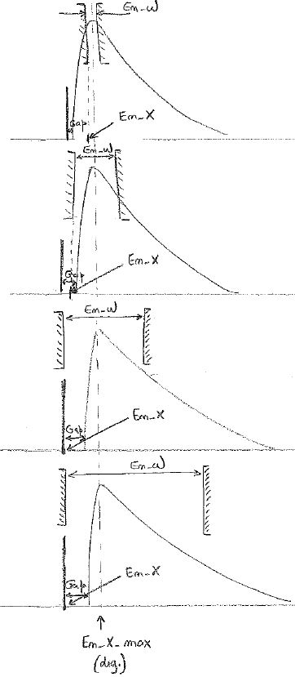

**The principle of energy slit centering**

***Calculation of the Energy Slit position***

The position of energy slit ***En\_X*** will be calculated from hereunder formulas with the parameters given in the following figure.

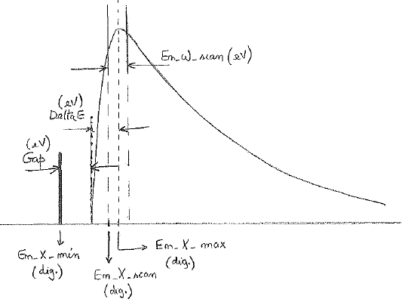

The En\_X\_max value (digits) that is the position of the energy slit corresponds to the maximum intensity is given by;

En\_X\_max = En\_X\_scan + (En\_W\_scan \* Y) / 2 (1)

with Y = 41 \* (5000 / Sample\_HV) (2)

En\_X\_scan (digits) is the result of the centering “Adjust”, En\_W\_scan (eV) is the opening of the slit to be used for the centering “Adjust”. This value is by default 5eV (stored in the Seup) . Y (digits/eV) is the conversion factor eV to digits. This Y factor is inversely proportional to the sample HV (e.g. Y=41 to Sample HV=5kV).

The En\_X\_min value (digits) which cannot be exceeding is calculated by flowing formula;

En\_X\_min = En\_X\_max – (Delta E + Gap) \* Y (3)

Delta E (eV) is the distance from zero to the maximum of energy distribution. This parameter is set in the Setup file as a default value equal to 5eV.

***Note*** *that Delta E(eV) value is obtained from the experiments performed on IMS 7F instrument using different impact energies.*

The Gap (eV) corresponds to 10% of the energy slit opening En\_W (eV) which is requested by the operator at the beginning of the “Adjust” procedure.

Gap (eV) = En\_W / 10 (4)

The symmetric opening of energy slit corresponds to the slit position:

En\_X\_sym (digits) = En\_X\_max – (En\_W \* Y) / 2 (5)

En\_X\_max (digits) is given by formula (1), En\_W (eV) is the energy slit opening at the beginning of the “Adjust” procedure, and Y (digits/eV) is the conversion factor given by formula (2).

As it is known that En\_X cannot be exceeding the limit En\_X\_min from the formula (3), the final calculation of En\_X (digits) is therefore;

En\_X = En\_X\_sym if En\_X\_sym ≥ En\_X\_min: (see formula 5)

En\_X = En\_X\_min if En\_X\_sym < En\_X\_min: (see formula 3)

[Contents ↑](#Contents)

### The Mass Resolution presets

Can be opened from the *Aperture and Mass Box*. Select  button.

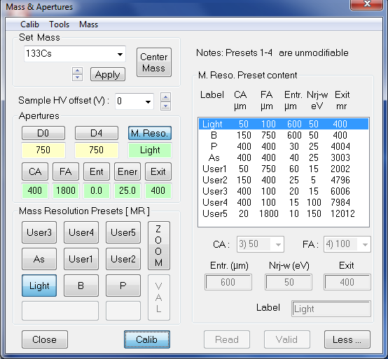

* **Mass resolution** is actually a "super-preset" which combines the 3 slits: *Entrance Slit*, *Exit Slit*, and *Energy Slit* and the 2 apertures: *Contrast aperture* and *Field Aperture*. This *super-preset* allows to move those five apertures and slits simultaneously.
* **4 presets (Light, B, P and As)** are fixed and they cannot be modified by users. These presets are dedicated to the typical analysis conditions, i.e. preset “Light” is set for the light element analysis, preset “B” is set for the B analysis, preset “P” is set for the P analysis, and preset “As” is set for the As analysis.
* **5 presets** remain editable presets with any combination of CA / FA / Ent / Ener / Exit.
* **Read** updates preset contents with the current configuration.
* **Valid** validates a preset setting modification.
* **Apply** loads the selected setting to the instrument.
* **Less** closes the extended Mass Resolution panel.

[Contents ↑](#Contents)

## The preset boxes (3): The detector box.

The "Detector box" can be opened by clicking ⮛ associated either to the button *Slit* or *Image* or *FC* or *EM*.

The "Detector box" consists of the *Preset pad*, at the left hand side, and the *Calib* box, at the right hand side, which must be opened only for modifying the content of a preset.

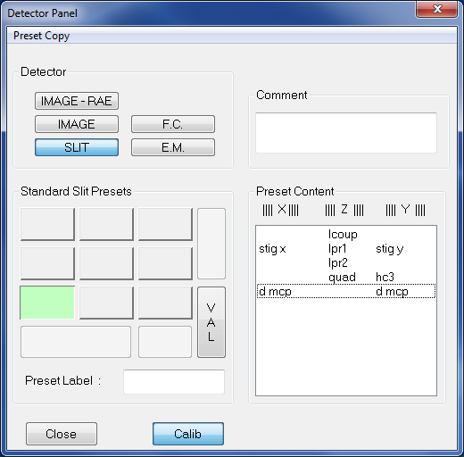

The rules of these 4 types of detector presets are slightly more complex and intricate than the standard rules. Refer to the section § [Slit, Image, FC, EM Presets](#_Presets_MCP_Image_et). Note, for example, that if *Slit* or *Image* are selected, up to 9 "Zoom" presets can be defined, but only *Lpr1* and *Lpr2* are specific to each zoom preset while the other parameters *Lcoup*, *Stig*.. are common for all the *Slit zoom* presets or for all the *Image zoom* presets.

|  |  |
| --- | --- |
|  | **Center** and **Adjust** functions are available for EM/FC detector mode.  opens the ***Scan All***dialog box then launches scanning sequence for the secondary beam centering on the detector. (See below for the sequence)  [*E.M. mode*](#_EM_Centering_automated_1)   * Scan and center ESA EXIT (X) * Scan and center DEM (Y)   [*F.C. mode*](#_FC_Centering_automated)   * Scan and center ESA EXIT (X) * Scan and center DFC (Y) * ***Note*** *that the new values will be automatically validated at the end of the scanning sequence.*   launches detector adjustment for a selected detector. (See below for the sequence)  [*E.M. mode*](#_EM_Adjust_automated)   * EM HV adjustment   [*F.C. mode*](#_FC_Adjust_automated)   * FC offset adjustment * ***Note*** *that the new values will be automatically validated at the end of the adjust routine.* |

[Contents ↑](#Contents)

### EM Centering automated routine

After clicking on the *Center* button on the E.M. Presets panel, the following routine is automatically performed:

***Note*** *that the primary beam current needs to be previously adjusted in order to have the secondary intensity about ~1e5 count/sec with EM detector.*

* The ***Scan All*** dialog box is opened
* The secondary ion intensity is collected by scanning the *ESA EXIT*: Range = 200 (digits) for sample HV = 5kV, the scanning range is proportional to the sample HV (e.g. the range will be 40 digits for sample HV = 1kV), Steps = 20, Wait time = Count. Time = 0.08 sec,
* The centering of *ESA EXIT* is determined at 50%, and then this value is applied.
* The secondary ion intensity is collected by scanning the *DEM*: Range = 2000 (digits) for sample HV = 5kV, the scanning range is proportional to the sample HV (e.g. the range will be 400 digits for sample HV = 1kV), Steps = 20, Wait time = Count. Time = 0.08 sec,
* The centering of *DEM* is determined at 50%, and then both *ESA EXIT* and *DEM* centered values will be automatically validated in the EM preset at the end of the scanning.

[Contents ↑](#Contents)

### FC Centering automated routine

After clicking on the *Center* button on the F.C. Presets panel, the following routine is automatically performed:

***Note*** *that the primary beam current needs to be previously adjusted in order to have the secondary intensity higher than ~1e7 count/sec with FC detector.*

* The ***Scan All*** dialog box is opened
* The secondary ion intensity is collected by scanning the *ESA EXIT*: Range = 200 (digits) for sample HV = 5kV, the scanning range is proportional to the sample HV (e.g. the range will be 40 digits for sample HV = 1kV), Steps = 20, Wait time = Count. Time = 0.08 sec,
* The centering of *ESA EXIT* is determined at 50%, and then this value is applied.
* The secondary ion intensity is collected by scanning the *DFC*: Range = 2000 (digits) for sample HV = 5kV, the scanning range is proportional to the sample HV (e.g. the range will be 400 digits for sample HV = 1kV), Steps = 20, Wait time = Count. Time = 0.08 sec,
* The centering of *DFC* is determined at 50%, and then both *ESA EXIT* and *DFC* centered values will be automatically validated in the FC preset at the end of the scanning.

[Contents ↑](#Contents)

### EM Adjust automated routine

After clicking on the *Adjust* button on the E.M. Presets panel, the following routine is automatically performed:

***Note*** *that the primary beam current needs to be previously adjusted in order to have the secondary intensity about ~1e5 count/sec with EM detector.*

* The ***Scan All*** dialog box is opened
* The *EM HV* routine is started. Refer to the user’s guide ***Scan all*** for the details.
* Adjusted *EM HV* value will be automatically validated in Setup at the end of the routine.

[Contents ↑](#Contents)

### FC Adjust automated routine

After clicking on the *Adjust* button on the F.C. Presets panel, the following routine is automatically performed:

* The ***Scan All*** dialog box is opened
* The *FC Offset* routine is started. Refer to the user’s guide ***Scan all*** for the details.
* Obtained *FC Offset* value will be automatically validated in Setup at the end of the routine.

[Contents ↑](#Contents)

## Center Secondary automated routine

This is a global routine for the automatic secondary alignment that is configurable by the operator. The *Secondary Centering Options* box can be opened by clicking the  buttons in the main *Tuning* menu bar.

|  |  |
| --- | --- |
|  | It is allowed to select centering elements of the secondary alignment by notching the checkbox in the list.   * *Note 1:* *Center Detector* and *Adjust Detectors* are available only when EM/FC mode is selected. * *Note 2:* *Center Entrance X* is only available for the HMR condition i.e. Exit preset > 1000, if not it is OFF. * *Note 3:* *Adjust HMR* is not yet available.   The secondary centering routine will be performed in the order below.   * Center Mass (Refer to [Center Mass](#_Center_Mass_routine)) * Center Detector (Refer to [Center Detector](#_EM_Centering_automated_1)) * Adjust Detectors (Refer to [Adjust Detector](#_EM_Adjust_automated)) * Adjust Energy (Refer to [Adjust Energy](#_Energy_Slit_automated)) * Center CA Apertures (Refer to [Center CA](#_Contrast_Aperture_automated)) * Center Entrance X (Refer to [Center Entrance](#_Entrance_Slit_automated) ) |

[Contents ↑](#Contents)

## The "Beam Position" and "Area Position" boxes

The *Beam position* box and the *Area position* box can be selected by clicking the so-labelled buttons in the main *Tuning* menu bar.

The *Beam Pos* box must be used whenever the operator wishes to shift all the *Primary beam* presets of the same value for the 3 parameters *Beam Pos X*, *Beam Pos Y*, *Last Lens.* This is recommended, for example, when it was checked that all the *Primary Beam* presets were well-centered and that it is required to shift all the presets either for building a new ISF or to compensate some external parasitic effect (e.g. an electrostatic edge effect).

The *Area Pos* box must be used whenever the operator wishes to shift all the *Max Area* presets of the same value for the 3 parameters *DTR X*, *DTR Y*, *Immersion Lens.*

|  |  |
| --- | --- |
|  |  |
| The kbd thumbwheels are assigned to *Beam Pos X*, *Lprim4,* *Beam Pos Y*. The operator has modified some of these settings.  **Apply** Shifts all the *Primary Beam* presets.  **Cancel** does not modify any *Primary Beam* presets. | The kbd thumbwheels are assigned to *DT FA X*, *Immersion Lens,* *and DT FA Y*. The operator has modified some of these settings.  **Apply** Shifts all the *Max Area* presets.  **Cancel** does not modify any *Max Area* presets. |

[Contents ↑](#Contents)

## The OIP Panel

Clicking the icon  in the top of the *Tuning* menu bar  opens the OIP panel displayed below.

This panel allows to store 9 set of OIP, or in other words 9 instrument configurations, all compatible with the same ISF, i.e. corresponding to the same MAP. For example, it is convenient to store a setting for saving the ISF, with all the apertures widely opened, and the *Image mode* selected, another setting corresponding to good conditions of sample imaging (small CA, narrow energy width), and finally another setting for checking the *Entrance slit* image (reduced FA, *Slit mode*)

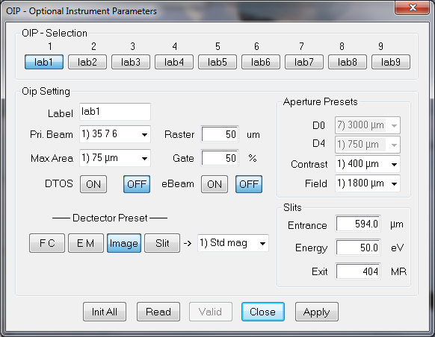

* At the top of the box it is possible to select 1 OIP setting among 9 possible. When selecting an OIP setting, the content of this setting is displayed in all the box fields.
* An OIP setting can be modified either by a *Read operation* or by modifying directly the OIP box.
* The in-the-box OIP setting modification is possible by editing the fields *Label*, *Raster*, *Gate*, by selecting a preset in the combo box *Primary Beam*, *Max Area*, *detector,* *Entrance*, *Energy*, *Exit, D0, D4, Contrast*, *Field* and by selecting a button *Slit/Image/EM/FC.*
* **Init All** fills all the settings with default values.
* **Read** updates an OIP setting with the current configuration.
* **Valid** validates an OIP setting modification after an *In-the-box* modification.
* **Close** closes the *OIP* box.
* **Apply** loads the selected setting to the instrument.

[Contents ↑](#Contents)

# The ion source control

## The Cs Source control

### Overview

The *Tuning* Cs Source control panels allow the operator to set the Cs Source ***High Voltage***, ***Ionizer current*** and ***Reservoir current***. The Cs Source High Voltage (or Accel HV) is chosen by the user according to analytical requirements. Both the ionizer and the reservoir currents are depending on the kind of Source (Refer to [*The CAMECA ion source user’s guide*](file:///D:\Notices\3.1.8\Notice%20Wf-ion%20source%201.doc)). The total Cs Source current (ionizer + reservoir + leakage currents) is not readable from the *Tuning* interface, but the leakage current can be read in the panel Tool/Diagnostic. The level of this leakage current gives an idea of the source aging.

In the *Ion source user's guide*, it is explained that for a given source accel HV, the reservoir current must be increased along the source life for keeping the same spot density. This increase is not achieved automatically. Practically, the user is advised to increase the reservoir current with the thumbwheels (See the section § [Synoptics](#_The_Synoptics_Reference)/ Sources)

Starting the Cs source, stopping it or switching the accelerating voltage involves automatic process under computer control. This is documented in the section § [The Cs Source Start Process](#_The_Cs_Source_1).

For the Cs source *Start Process* may be run according to different modes:

* The **normal mode**, typically targeted for switching the source from OFF to ON or from ON to OFF. It is activated whenever one considers a variation of the source heating power.
* The **fast mode**, typically targeted for switching the accelerating voltage while keeping the small variation of heating power.

For the Cs source *Stop Process* may be run by one normal mode:

* The **normal mode**, typically targeted for switching the source from ON to OFF. It is activated whenever one considers a variation of the source heating power.

[Contents ↑](#Contents)

### The Cs source Start Process

The Cs source *Start Process* is activated in 2 cases:

* When the operator clicks *START* in the [Cs source Start/Stop panel](#_The_Start/Stop_CS).
* When a new ISF is loaded (See the section § [Loading and Saving an ISF](#_Loading_and_saving)), if the new ISF accel HV is not the current one.

Any Cs source *Start Process* can be defined by the set of 3 initial parameters and 3 final parameters

|  |  |
| --- | --- |
| Initial Accel HV | Final Accel HV |
| Initial ionizer current | Final ionizer current |
| Initial reservoir current | Final reservoir current |

The initial parameters are the instrument current parameters. The final parameters may be the last saved parameters in *Set-Up* or the parameters saved in ISF file to load.

**The Normal/Fast mode test**

As for the *Start Process,* at the beginning of the Cs *Start Process*, a test is firstly achieved for running the process either under the *Normal mode* or under the *Fast mode*.

|  |  |  |
| --- | --- | --- |
|  | Test criterion:  If Cs source HV < 500 (digits) **or** Ionizer < 50 (digits) **or** Reservoir < 20 (digits),  Then, it is considered as the source OFF; therefore the ***Normal mode*** will be applied.  If Cs source HV > 500 (digits) **and** Ionizer > 50 (digits) **and** Reservoir > 20 (digits),  Then, it is considered as the source ON; therefore the ***Fast mode*** will be applied. |  |

**The Normal mode Cs source *Start Process***

* Step 1: The *Cs Accelerating Voltage* is driven in 10 steps from its initial value (typ 0) to its final value.
* Step 2: The *Ionizer Current* is continuously increased from its initial value (typ 0) to its final value. The increase is calculated from total *Ionizer Current* (mA or digits) divided by the *Heating Slope* duration. (e.g. if Ionizer final = 240 digits, Heating slope = 120 sec, then, the increase is 2 digits/sec.) This heating ramp duration can be edited in the [The Cs Source Set-up parameter advanced panel](#Cs_advanced_panel) (Ionizer *heating slope*).
* Step 3: Once the *Ionizer current* reaches to the final value, the source is on standby before start to heat the *Reservoir*. This waiting time can be edited in the [The Cs Source Set-up parameter advanced panel](#Cs_advanced_panel) (Ionizer *Stabilization*)
* Step 4: The *Reservoir Current* is continuously increased from its initial value (typ 0) to its final value. The increase is calculated from total *Reservoir Current* (mA or digits) divided by the *Heating Slope* duration. (e.g. if Reservoir final = 120 digits, Heating slope = 120 sec, then, the increase is 1 digit/sec.) This heating ramp duration can be edited in the [The Cs Source Set-up parameter advanced panel](#Cs_advanced_panel) (Reservoir *heating slope*).

The overall slow mode *Start Process* duration is typically of 600 sec.

**The Fast mode of the Cs source *Start Process***

The set of 3 Cs source parameters (Accel HV, Ionizer current, and Reservoir current) is continuously increased from the initial values to the final values in 10 steps with 1 second per step while keeping the same heating power.

Heating Power ionizer = Accel HVint × Iionizer int = Accel HVfin × Iionizer fin

Heating Power reservoir = Accel HVint × Ireservoir int = Accel HVfin × Ireservoir fin

The overall fast mode *Start Process* duration is 10 seconds.

### The Cs source Stop Process

The Cs source *Stop Process* is activated in a single case, when the operator clicks *STOP* in the [Start/Stop Cs source panel](#_The_Start/Stop_CS).

**The Normal mode Cs source *Stop Process***

* Step 1: The *Reservoir Current* is continuously decreased from its initial value to zero. The decrease is calculated from total *Reservoir Current* (mA or digits) divided by the *Cooling Slope* duration. (e.g. if Reservoir initial = 120 digits, Cooling slope = 120 sec, then, the decrease is 1 digit/sec.) This cooling ramp duration can be edited in the [The Cs Source Set-up parameter advanced panel](#Cs_advanced_panel) (Reservoir *cooling slope*).
* Step 2: Once the *Reservoir current* reaches to zero, the source is on standby before start to cool down the *Ionizer*. This waiting time can be edited in the [The Cs Source Set-up parameter advanced panel](#Cs_advanced_panel) (Reservoir *Waiting time*)
* Step 3: The *Ionizer Current* is continuously decreased from its initial value to zero. The decrease is calculated from total *Ionizer Current* (mA or digits) divided by the *Cooling Slope* duration. (e.g. if Ionizer initial = 240 digits, Cooling slope = 120 sec, then, the decrease is 2 digits/sec.) This cooling ramp duration can be edited in the [The Cs Source Set-up parameter advanced panel](#Cs_advanced_panel) (Ionizer *cooling slope*).
* Step 4: Once the *Ionizer current* reaches to zero, the source is on standby before start to decrease the *Accel HV*. This waiting time is the non-programmable delay displayed in the [The Cs Source Set-up parameter advanced panel](#Cs_advanced_panel).(Ionizer *Waiting time=100 sec*)
* Step 5: The *Cs Accelerating Voltage* is driven in 10 steps from its initial value to zero.

The overall slow mode *Stop Process* duration is typically of 750 sec.

[Contents ↑](#Contents)

### The Cs source Start/Stop panel

Clicking the icon  in the top of the *Tuning* menu bar  opens the property box displayed below.

☞ Select the *Cs* tab.

|  |  |
| --- | --- |
| **Cs source Starting Mode** | * **Analogic/digital** Selection radiobutton. If *Analogic*, the source parameters are displayed in the box in physical units (Volts or mA). If *Digital* they are displayed in no-unit digits, as they are displayed in the *Real Time Screen*. * **ON Source Accel** displays the accel HV as it is in the current ISF. * **ON Reservoir** displays the reservoir current as it was at the last *Stop Source.* * **ON Ionizer** displays the ionizer current as it was at the last *Stop Source.* * **Stop** button for activating the Cs source *Stop* process. See above [The Cs source stop process](#_The_Cs_Source_2). * **Start** button opens *Heating Source & Working* panel (displayed on the left hand side) for selecting the Cs source *Starting Mode*.   ***Note*** *that start source is automatically performed by following procedure.*   * Source Heating & Working : * Cs source chamber valve is opened (if closed). * Cs source moves to the *Work Position* inside of the primary column (if not yet done). * Cs source heating is started (Accel HV, Ionizer, Reservoir; refer to the [The Cs Source Start Process](#_The_Cs_Source)). * Source Heating only : * Cs source heating is started (Accel HV, Ionizer, Reservoir; refer to the [The Cs Source Start Process](#_The_Cs_Source)) at *Home position* without displacement of Cs source and without changing the valves status. * **Pause** button suspendseither the *Stop* or the *Start* process. * **Close** closes Start/Stop sources Panel. |

|  |  |
| --- | --- |
| **Cs source differed stopping Box**    **Cs source differed starting Box** | button opens *All Stop Sources* panel displayed on the left hand side. This panel allows to program the stopping the sources.   * Source selection: Cs/Duo/NEG . * Cs source position: At Home/At Work. * Stopping date & time. * then, **Apply** and **Close.**   button opens *Differed starting for source Cesium* panel displayed on the left hand side. This panel allows to program the starting of the sources.   * ISF file selection: set Cs source Accel HV, Reservoir current and Ionizer current to start. * Selection of the Cs source starting Mode * Source Heating & Working. * Source Heating only.   (see above for the details)   * then, **Apply** and **Close.** |

[Contents ↑](#Contents)

### The Cs source set-up parameter panel

Click *Setup* at the top of the *Tuning* menu bar

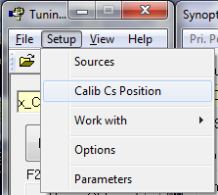

A menu lists 3 possible selections: *Sources / Calib Cs Position / Work with.* Select *Sources* for opening the *Source Setup* property box.

**The Cs Setup Source Properties main panel**

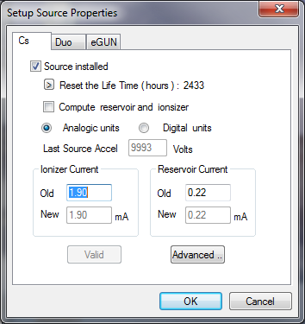

* **Source installed** if this check box is checked the source corresponding to the selected tab (e.g. Cs) will be recognized by the software (e.g. menu *Setup/Work with*) (Setup #710)
* **Reset the Life time** resets Cs running time to zero. It is useful to monitor Cs life time when Cs source is newly changed.
* **Compute reservoir and ionizer** if this check box is notched, Cs source is turned on by computed reservoir and ionizer values from a given formula linked to the Cs Acceleration Voltage. If this option is not selected, the source is turned on by either the last valid values or the contained values in a selected ISF file in case of a differed starting mode.
* **Analog units/digital units** Selection. If *Analog units*, the source parameters are displayed the box in physical units (Volts or mA). If *Digital units* they are displayed in no-unit digits, as they are displayed in the *Real Time Screen*.
* **Last Source Accel** Edit Field. The default displayed value is the *Last Valid source accel* contained in the current ISF. It can be re-edited for starting the source
* **Advanced** opens the [Cs source setup parameter advanced panel](#Cs_advanced_panel).

**The Cs Source Set-up parameter advanced panel**

Path: Setup/Sources + Click *Advanced*

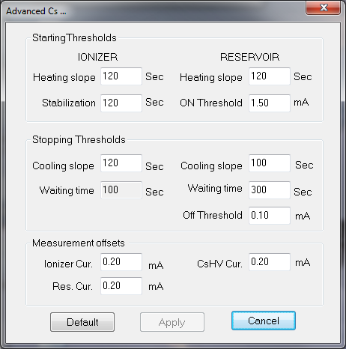

IONIZER

* **Heating slope** displays and edits the ionizer heating duration during the [*Start Cs Source Process*](#Cs_source_start). (set-up #727)
* **Stabilization** displays and edits the delay which occurs after the ionizer heating during the [*Start Cs Source Process*](#Cs_source_start). (set-up #728)
* **Cooling Slope** displays and edits the ionizer cooling duration during the [*Stop Cs Source Process*](#Cs_source_stop). (set-up #730)
* **Waiting time** displays the non-programmable delay which occurs after the ionizer cooling during the [*Stop Cs Source Process*](#Cs_source_stop).

RESERVOIR

* **Heating slope** displays and edits the reservoir heating duration during the [*Start Cs Source Process*](#Cs_source_start). (set-up #729)
* **ON Threshold** displays and edits the total Cs source current (reservoir + ionizer + leakage).(set-up #740)
* **Cooling slope** displays and edits the reservoir cooling duration during the [*Stop Cs Source Process*](#Cs_source_stop). (set-up #732)
* **Waiting time** displays and edits the delay which occurs after the reservoir cooling during the [*Stop Cs Source Process*](#Cs_source_stop). (set-up #731)
* **Off Threshold** displays and edits the total Cs source current (reservoir + ionizer + leakage). (set-up #741)

MEASUREMENT OFFSETS

* *Ionizer cur.*, *Res Cur.*, *Cs HV Cur.* (Set-up #736, 737, 738)

**The Cs Setup/Calib Cs Position panel**

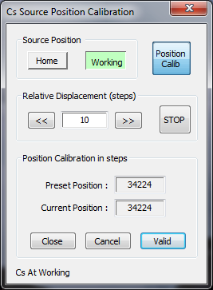

* **Source Position** the Cs source can be loaded and unloaded by clicking *Home* or *Working* buttons.
* *Home*: Cs source moves into the Cs source chamber.
* *Working*: Cs source enters into the primary column.
* **Position Calib** allows to move manually Cs source position if it is necessary. By clicking this button, following *Relative Displacement* area turns to be editable.
* **Relative Displacement** shifts Cs source position along X direction by taking the assigned steps. Once the source is well centered in the primary column, it is recommended to validate this new position using *Valid* button.
* **Position Calibration in steps** displays the lastly validated source position and the current position in step unit.
* **Close** closes the *Cs Source Position Calibration* box.
* **Cancel** cancels the modification of the Cs source position.
* **Valid** validates new Cs source position.

[Contents ↑](#Contents)

### The Cs source links with the Setup file

|  |  |  |
| --- | --- | --- |
| # | **Set-up Label** | **Comments** |
| 710 | Col60 Cesium present | *Tuning/Setup/Source/Cs* |
| 727 | Cs ionizer on ramp delay | *Tuning/Setup/Source/Advanced* used in the *Start Process* |
| 728 | Cs ionizer heating delay | *Tuning/Setup/Source/Advanced* used in the *Start Process* |
| 729 | Cs reservoir on ramp delay | *Tuning/Setup/Source/Advanced* used in the *Start Process* |
| 730 | Cs ionizer OFF ramp delay | *Tuning/Setup/Source/Advanced* used in the *Stop Process* |
| 731 | Cs reservoir cooling delay | *Tuning/Setup/Source/Advanced* used in the *Stop Process* |
| 732 | Cs reservoir OFF ramp delay | *Tuning/Setup/Source/Advanced* used in the *Stop Process* |

[Contents ↑](#Contents)

## The Duo Source control

### Overview

The *Tuning* Duo Source control panels allow the operator to set the Duo Source ***High Voltage***, ***Arc current*** and ***coil current*** and to run the procedures [Duo Start Process](#_The_Duo_source_2) and [Duo Stop Process](#_The_Duo_Stop). The Duo Source High Voltage (or Accel HV) is chosen by the user according to analytical requirements. Both the *Arc* and the *coil* currents are not depending upon this accelerating High Voltage (Refer to [*The CAMECA ion source user’s guide*](file:///D:\Notices\3.1.8\Notice%20Wf-ion%20source%201.doc#Duo)).

It is also possible to modify the source parameters from the synoptics panel.

### The Duo source *Start Process*

The *Duo Start process* is normally launched from the [Duo Start/Stop panel](#_The_Duo_source_2)

* Vacuum HV security test
* Set arc current.
* Set coil current
* Open the duo O2 leakage Valve
* waiting time (IARC delay, Setup # 754, 759)
* Test arc current : test= (measured arc current – ISF arc current)/(ISF arc current)

where *ISF arc current* is the ISF value in digits multiplied by 0.024.

if (test < - Arc current tolerance), [*Duo Stop Process*](#_The_Duo_Stop)

Arc current tolerance editable in the [Duo setup panel](#_The_Duo_source_1)

* Set Duo HV
* waiting time (Duo HV delay, Setup # 755, 760)
* test duo HV: test= (measured duo HV – ISF duo HV)/(ISF duo HV)

if (test < - Duo HV tolerance), [*Duo Stop Process*](#_The_Duo_Stop)

Duo HV tolerance editable in the [Duo setup panel](#_The_Duo_source_1)

* Duo is ready

### The Duo source Stop Process

The *Duo Stop process* is normally launched from the [Duo Start/Stop panel](#_The_Duo_source_2)

* Close the duo O2 leakage Valve
* Set HV=0
* Set coil=0
* Set Arc=0

### The Duo source Start/Stop panel

Clicking the icon  in the top of the *Tuning* menu bar  opens the property box displayed below.

☞ Select the *Duo* tab.

|  |  |
| --- | --- |
| **Duo source Starting Mode** | * **Analogic/digital** Selection radiobutton. If *Analogic*, the source parameters are displayed the box in physical units (Volts or mA). If *Digital* they are displayed in no-unit digits, as they are displayed in the *Real Time Screen*. * **ON Source Accel** displays the accel HV as it is in the current ISF. * **ON Arc Source** displays the Arc current as it was at the last *Stop Source*. * **ON Coil current** displays the coil current as it was at the last *Stop Source*. * **Stop** button for activating the [Duo source *Stop* process](#_The_Duo_Stop). * **Start** button opens *Heating Source & Working* panel displayed on the left hand side for selecting the Duo source *Starting Mode*.   ***Note*** *that start source is automatically performed by following procedure.*   * Source Heating & Working : * Duo source chamber valve is opened (if closed). * Duo source is started (Accel HV, Arc current, Coil current; refer to the [The Duo Source Start Process](#_The_Duo_source)). * Source Heating only : * Duo source is started (Accel HV, Arc current, Coil current; refer to the [The Duo Source Start Process](#_The_Duo_source)) without changing the duo valve status. * **Pause** button suspendseither the *Stop* or the *Start* process. * **Close** closes Start/Stop sources Panel. |

|  |  |
| --- | --- |
| **Duo source differed stopping Box**    **Cs source differed starting Box** | button opens *All Stop Sources* panel displayed on the left hand side. This panel allows to program the stopping the sources.   * Source selection: Cs/Duo/NEG. * Duo source position: At Home/At Work. * Stopping date & time. * then, **Apply** and **Close.**   button opens *Differed starting for source Duo* panel displayed on the left hand side. This panel allows to program the starting of the sources.   * ISF file selection: set Duo source Accel HV, Arc current and Coil current to start. * Selection of the Duo source starting Mode. * Source Heating & Working. * Source Heating only.   (see above for the details)   * then, **Apply** and **Close.** |

[Contents ↑](#Contents)

### The Duo source set-up parameter panel

Click *Setup* at the top of the *Tuning* menu bar



A menu lists 2 possible selections: *Sources* and *Work with*. Select *Sources* for opening the *Source Setup* property box.

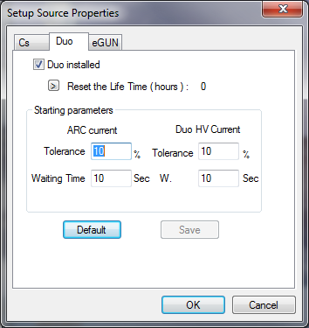

* **Duo installed** if this check box is checked, the source corresponding to the selected tab (e.g. Duo) will be recognized by the software (e.g. menu *Setup/Work with*) (Setup #711).
* **Reset the Life time** resets Duo running time to zero. It is useful to monitor Duo life time when Duo source is newly cleaned up.
* **Arc current Tolerance (%)** edits the tolerance used in the *arc Current test* which is performed in the [Duo Start Process](#_The_Duo_source). (Setup #751)
* **Arc current waiting time (s)** edits the waiting time included in the [Duo Start Process](#_The_Duo_source). (Setup #754).
* **Duo HV Tolerance (%)** edits the tolerance used in the *Duo HV test* which is performed in the [Duo Start Process](#_The_Duo_source). (Setup #752).
* **Duo HV waiting time (s)** edits the waiting time included in the [Duo Start Process](#_The_Duo_source). (Setup #755).
* **Default** resets all parameters to the default values as it is shown above.
* **OK** validates the modified edited fields and writes them in the *Setup file*.
* **Cancel** closes the box without taking into account the edited modifications.

[Contents ↑](#Contents)

### The Duo source links with the Setup file

|  |  |  |
| --- | --- | --- |
| # | **Set-up Label** | **Comments** |
| 711 | Col60 Duo present | *Tuning/Setup/Source/Duo* |
| 751 | Duo60 Arc Current Tolerance | *Tuning/Setup/Source/Duo* |
| 752 | Duo60 HV Current Tolerance | *Tuning/Setup/Source/Duo* |
| 753 | Duo60 HV Restart Delay | *Tuning/Setup/Source/Duo* |
| 754 | Duo60 IARC Delay | *Tuning/Setup/Source/Duo* |
| 755 | Duo60 HV Delay | *Tuning/Setup/Source/Duo* |

## The E-GUN Source Control

### Overview

Refer to the [Normal Electron Gun (NEG) user’s guide](file:///D:\Notices\3.1.8\Notice%20Wf-NEG.doc)

### The E-GUN Start Process

The *E-Gun Start process* is normally launched from the [E-Gun Start/Stop panel](#_The_E-GUN_Start/Stop)

* Test Vacuum
* Set E-Gun HV (2")
* Set the wehnelt voltage at maxi
* Set the filament heating current
* Set the emission current (served by the wehnelt voltage)
* Test heating current

if (measured heating current=0), message "Filament broken"

E-gun Stop Process

* test emission current

if (measured emission current) outside ISF emission current ± Tolerance

Message "Emission current out of range"

(Tolerance= EGUN current tolerance, Setup #761)

* Message "EGUN Ready"

### The E-GUN Stop Process

The *E-Gun Stop process* is normally launched from the [E-Gun Start/Stop panel](#_The_E-GUN_Start/Stop)

* Set the filament heating current to zero
* Set E-Gun HV to zero.
* Set all the e-gun parameters to zero (including the coils BX e-, BY e-)
* Message "Stop NEG completed"

[Contents ↑](#Contents)

### The E-GUN Start/Stop panel

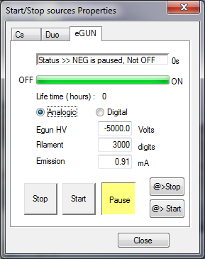

*Note:* at first start (normally done at the factory), one must select eGUN and Start in this panel. After that, the eGUN high voltage, filament and emission have to be adjusted. Finally one must click the e-BEAM ON button in the Tuning Master Panel.

### The E-GUN set-up parameter panel

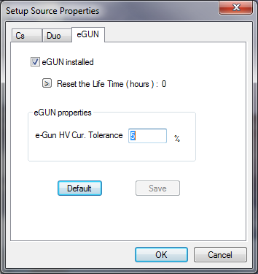

* **eGUN installed** : if this check box is ticked, the e-gun source will be recognized by the software (e.g. menu *Setup/Work with*) (Setup #714)
* **Reset the Life time** resets eGUN running time to zero. It is useful to monitor eGUN life time when eGUN filament is newly changed.
* **eGUN HV current Tolerance (%)** edits the tolerance used in the *eGun emission current test* which is performed in the [eGun Start Process](#_The_E-GUN_Start). (Setup #761)
* **Default** resets all parameters to the default values.(e.g. Tolerance default value=10%)
* **OK** validates the modified edited fields and writes them in the *Setup file*.
* **Cancel** closes the box without taking into account the edited modifications.

### The E-gun source links with the Setup file

|  |  |  |
| --- | --- | --- |
| # | **Set-up Label** | **Comments** |
| 714 | E-Gun present | *Tuning/Setup/Source/E-Gun* |
| 761 | EGUN current Tolerance | *Tuning/Setup/Source/E-Gun* |

[Contents ↑](#Contents)

# The Tuning Reference guide

## The ISF parameters list

### The source parameters

**Parameters stored in the ISF, available from the keyboard thumbwheels**

|  |  |
| --- | --- |
| **Tuning Labels** | **Comment** |
| SOURCE | Duo/Cs |
| ACCEL HV | Souce acceleration voltage |

**Parameters stored in the set-up table, available from the keyboard thumbwheels**

|  |  |
| --- | --- |
| **Tuning Labels** | **Comment** |
| ARC | Duoplasmatron arc current (if Source=Duo) |
| COIL | Duoplasmatron coil current (if Source=Duo) |
| RESERVOIR | Reservoir electron current (if Source=Cs) |
| IONIZER | Ionizer electron current (if Source=Cs) |

[Contents ↑](#Contents)

### The primary parameters

**Primary parameters stored in the ISF, available from the keyboard thumbwheels**

|  |  |
| --- | --- |
| **Tuning Label** | **Comment** |
| DUO ACL | Duo Accel-Decel lens |
| Duo L1 | Primary column first lens |
| WIEN LENS | Primary column Wien lens |
| L2 | Primary column second lens |
| L3 | Primary column third lens |
| L4 | Primary column fourth lens |
| DP 1 X&Y | Primary column deflector in front of L1 |
| DP WL X&Y | Primary column deflector in front of WL |
| WIEN DY | Wien filter electrostatic plate |
| WIEN COIL | Wien filter coil. |
| D0 | Primary beam aperture D0 |
| D4 | Primary beam aperture D4 |
| DP 3a X&Y | Primary column deflector in front of D0 |
| DP 3b X&Y | Primary column deflector in front of L3 |
| DP 4 X&Y | Primary column deflector in front of D4 |
| BEAM POS X&Y | Primary Beam Position X, Primary Beam Position Y |
| STIG 45 & STIG 90 | Primary Stig 45 deg and Primary Stig 90 deg |
| D5 S1 | Primary column quadrupole |
| DEF\_FC | Primary Faraday Cup Deflection. |
| RASTER X&Y | Primary Raster |
| FCP REP | Primary Faraday Repeller |

**Primary parameters stored in the ISF, not available from the keyboard thumbwheels**

|  |  |
| --- | --- |
| **Tuning Label** | **Comment** |
| Normal Source HV | Last acceleration voltage involved in a VALID+Source HV |
| maximum field X&Y | Maximum rastered field in X and Y (Raster=4095)  Computed when VALID + Raster |
| Raster ON/OFF | Boolean for the primary Raster.  Set in the main Tuning menu bar |
| BBP gate (%) | Boolean for the primary Faraday sampling mode  Set in *Centering Tools 7FAuto/FCp/Setup.* |
| Prim Pol | Primary ion polarity |

**Primary parameters stored in the *set-up file*, available from the keyboard thumbwheels**

|  |  |
| --- | --- |
| **Tuning Label** | **Comment** |
| ROT Y | Primary raster Y rotation (Setup # 717) |

[Contents ↑](#Contents)

### The secondary parameters

**Secondary parameters stored in the ISF, available from the keyboard thumbwheels**

| **Tuning Label** | **Comment** |
| --- | --- |
| SAMPLE HV | Sample HV, Secondary acceleration Voltage |
| LIMM | Immersion lens |
| DT FA X&Y | Secondary beam centering in the FA Plane (Transfer line) |
| DT CA X&Y | Secondary beam centering in the CA Plane (Transfer line) |
| COEF FA X&Y | coefficients for linking DT1 and DT3 in DT CA |
| COEF CA X&Y | coefficients for linking DT1 and DT3 in DT FA |
| STIG-X, STIG-Y | Transfer line stigmator |
| LTR1 | 1st Transfer lens |
| LTR2 | 2nd Transfer lens |
| CONT APER X&Y | Contrast Aperture (CA) |
| ENT SL X&W | Entrance Slit, position and Width. |
| FIELD APER X&Y | Field Aperture (FA) |
| ESA | Spectrometer Electrostatic Sector (ESA) |
| LCOUP | Spectrometer Lens (Coupling line) |
| HC3 (SEX) | Sextupole (Coupling line) |
| DC2 Y | Secondary beam centering at the magnet exit (Projection line) |
| SLIT STIG X&Y | XY Stigmator, for focusing the exit beam (Projection line) |
| IMA STIG X&Y | XY Stigmator, for the exit beam rotation. |
| DT Raster X&Y | Secondary Raster synchronized with the primary Raster. |
| DT ROT X&Y | Dynamic Transfer Rotation |
| E.GATE W X&Y | Electronic gate width dimensions |
| LPR1 | 1st Projection Lens |
| LPR2 | 2nd Projection Lens |
| EXIT ESA | Exit ESA |
| EM-DY | Switching deflector in front of FC/EM. EM Deflection |
| FC-DY | Switching deflector in front of FC/EM. FC Deflection |
| DPR X&Y | XY Projection deflector (Projection line) |
| MCP X&Y | Last deflector (Projection line) |
| ENER SL X&W | Energy Slit position and Width |
| BBS DEF | Secondary Beam Blanking Deflection |
| EXIT SL W | Exit Slit width |

**Secondary parameters stored in the ISF, not available from the keyboard thumbwheels**

|  |  |
| --- | --- |
| **Parameter Label** | **Comment** |
| Normal Sample HV | Last secondary voltage involved in a VALID+Sple HV |
| Slit/Image/FC/EM preset | Selected MCP and detection mode |
| max field DTR raster X&Y | Maximum DT rastered field in X and Y (Raster=4095)  Computed when VALID+Raster or VALID+DT |
| Dynamic Transfer (Y/N) | Boolean, for DT Y/N |
| Electronic gate (Y/N) | Boolean, for Electronic Gate Y/N |
| Sec Polarity | Secondary polarity. |

**Secondary parameters stored in the set-up table, available from the kbd thumbwheels**

|  |  |
| --- | --- |
| **Tuning Label** | **Comment** |
| EM HV | EM High Voltage (Setup # 37) |
| EM THRES | EM discriminator threshold (Setup # 36) |
| FDY RPL | Secondary Faraday repeller (Setup # 773) |
| CP SCINT | Fluo Screen HV (Setup # 518) |
| DET PA HV | EM Post acceleration voltage. (Setup #38) |

[Contents ↑](#Contents)

### The NEG (E-Gun) Parameters

**NEG parameters stored in the ISF, available from the keyboard thumbwheels**

|  |  |
| --- | --- |
| **Tuning Label** | **Comment** |
| HV | NEG High Voltage |
| FILAMENT | Electron gun filament heating |
| EMISSION | NEG emission current |
| Le- | NEG Lens |
| QUAD E- | NEG Stigmator XY |
| DEF1 e- X&Y | NEG 1st deflector |
| DEF2 e- X&Y | NEG 2nd deflector |
| BX | Electron magnetic Def X |
| BY | Electron magnetic Def Y |
| COIL COEFF | Electron coil coupling coefficient (Byb/Bya) |

**NEG parameters stored in the ISF, not available from the keyboard thumbwheels**

|  |  |
| --- | --- |
| **Parameter Label** | **Comment** |
| Normal NEG HV | Last e-gun voltage involved in a VALID+E- HV |
| NEG (Y/N) | Boolean for NEG ON/OFF |

### Imaging Parameters

**Parameters stored in the set-up table, available from the keyboard thumbwheels**

|  |  |
| --- | --- |
| **Tuning Label** | **Comment** |
| CCD BRGHTNSS | (Setup # 530) |
| CCD CNTRST | (Setup # 531) |
| CCD RTNTN | (Setup # 532) |
| RAE BRGHTNSS | (Setup # 527) |
| RAE CNTRST | (Setup # 528) |
| RAE RTNTN | (Setup # 529) |
| SII BRGHTNSS | (Setup # 519) |
| SII CNTRST | (Setup # 520) |
| SII RTNTN | (Setup # 521) |
| RAE HV | (Setup # 526) |

SEI parameters (Setup # 522, 523, 524, 525) are not available for the IMS 7f-Auto.

[Contents ↑](#Contents)

## The Synoptics Reference Guide

### Sources

|  |  |  |  |
| --- | --- | --- | --- |
| Synoptics selection | X | Z | Y |
| Cesium | IONIZER | CS HV | RESERVOIR |
| DUO | ARC CUR | DUO HV | COIL CUR |

### Primary column

|  |  |  |  |
| --- | --- | --- | --- |
| Synoptics selection | X | Z | Y |
| L1 + L2 + L3 |  | DUO ACL |  |
|  | DP 1 | Duo L1 | DP 1 |
|  | DP WL | WIEN LENS | DP WL |
|  | WIEN COIL | WIEN LENS | WIEN DY |
|  | DP 3a |  | DP 3a |
|  | DP WL | L2 | DP WL |
|  | D0 | L2 | D0 |
|  | DP 3b | L3 | DP 3b |
|  |  | DEF FC |  |
| L4 | D4 | L4 | D4 |
|  | DP 4 | L4 | DP 4 |
|  | BEAM POS | L4 | BEAM POS |
|  | STIG 45 | L4 | STIG 90 |
|  | D5 S1 |  |  |
|  | FCP REP | DEF FC | GATE Y |
|  | RASTER X |  | RASTER Y |
|  | ROT Y |  |  |

[Contents ↑](#Contents)

### Secondary

| Synoptics selection | X | Z | Y |
| --- | --- | --- | --- |
| Sample |  | SPL HV |  |
| Immersion | BEAM POS | LIMM | BEAM POS |
|  | STIG-X | LIMM | STIG-Y |
| Dyn. Transfer | DT RASTER |  | DT RASTER |
|  | DT ROT X |  | DT ROT Y |
| Transfer | DT FA | LTR1 | DT FA |
|  | DT FA | LTR2 | DT FA |
|  | DT CA | LTR2 | DT CA |
|  | COEF. FA | LTR1 | COEF. FA |
|  | COEF. CA | LTR2 | COEF. CA |
|  | CA |  | CA |
|  | ENT SL |  | ENT SL |
|  | FA |  | FA |
| Spectrometer |  | LCOUP | ESA |
|  |  | LCOUP | SPL HV |
|  |  | HC3 | DC2 |
|  |  | EPS | DC2 |
|  | ENRG SL | LCOUP | ENRG SL W |
| Projection | DPR X | LPR1 | DPR Y |
|  | DPR X | LPR2 | DPR Y |
|  | STIG X | QUAD | STIG Y |
|  |  |  | EXT SL |
|  | D MCP |  | D MCP |
|  |  | CP SCINT |  |
|  |  | BBS DEF |  |
| EM | ESA EXIT |  | DEM |
|  | EM THRES | EM HV | EM PAHV |
| FC | ESA EXIT |  | DFC |
|  |  | FC REP |  |
| Electronic gate | E.GATE W |  | E.GATE W |

[Contents ↑](#Contents)

### Egun

| Synoptics selection | X | Z | Y |
| --- | --- | --- | --- |
| e-Gun | FILAMENT | EGUN HV | EMISSION |
|  | FILAMENT | WEHNELT | EMISSION |
|  | BX e- |  | BY e- |
|  | D1 | Le- | D1 |
|  | D2 | Le- | D2 |
|  |  | QUAD e- |  |
|  |  |  | ION COEF |

### RAE

| Synoptics selection | X | Z | Y |
| --- | --- | --- | --- |
| RAE | DMCP | LTR1 | DMCP |
|  | DMCP | LTR2 | DMCP |
|  |  | RAE HV |  |

### Apertures

| Synoptics selection | X | Z | Y |
| --- | --- | --- | --- |
| Apertures | CA | LTR1 | CA |
|  | FA | LTR1 | FA |
|  | ENT SL (\*) |  | ENT SL(\*) |
|  | ENRG SL (\*) | LCOUP | ENRG SL W (\*) |
|  |  | LPR1 | EXT SL(\*) |
|  | D0 | L2 | D0 |
|  | D4 | L4 | D4 |

(\*) X parameters shift the slit position without changing its width (not available for Exit slit), Y parameters correspond to the slit width.

### Imaging

| Synoptics selection | X | Z | Y |
| --- | --- | --- | --- |
| Imaging | RAE BRGH | RAE RTNT | RAE CNTR |
|  | CCD BRGH | CCD RTNT | CCD CNTR |
|  | SII BRGHT | SII RTNT | SII CNTR |
|  |  | SII RTNT | GAIN |

[Contents ↑](#Contents)

## The Preset Reference Guide

### Primary beam, Ion beam ON/OFF, Beam Pos

List of the Primary Beam preset parameters:

|  |  |  |
| --- | --- | --- |
| X | Z | Y |
| dp 1 | Duo l1 | dp 1 |
| dp wl | wien lens | dp wl |
| dp wl | l2 | dp wl |
| dp 3a | l3 | dp 3a |
| dp 3b | l3 | dp 3b |
| dp 4 | l4 | dp 4 |
| beam pos | l4 | beam pos |
| stig 45 | l4 | stig 90 |
| d5 s1 | l4 |  |

**Labels:**

The labels are alphanumerical labels to be defined by the user. It can be for example the spot current in nA.

***Beam Pos* Drift correction**

Clicking *Beam Pos* assign to the keyboard thumbwheels:

|  |  |  |
| --- | --- | --- |
| X | Z | Y |
| B. POS X | LPRIM 4 | B. POS Y |

The Tuning is then in the status *Beam pos*. It is possible to get out of *Beam Pos* either by clicking on Apply or Cancel (as explained in [The Beam position and Area Position boxes](#_The_OIP_Panel)):

- Apply shifts all the *Primary Beam* preset

- Cancel does not modify any *Primary Beam* preset.

**Ion Beam ON/OFF**

Clicking *Ion Beam OFF* produces a continuous primary beam blanking deflection towards the primary Faraday cup *FCp*.

[Contents ↑](#Contents)

### Maximum area

List of the Maximum Area preset parameters:

|  |  |  |
| --- | --- | --- |
| X | Z | Y |
| stig-x | limm | stig-y |
| dt fa | ltr 1 | dt fa |
| dt ca | ltr 2 | dt ca |
| coef.fa | ltr 1 | coef.fa |
| coef.ca | ltr 2 | coef.ca |

**Labels**

The labels are numerical (µm) or alphanumerical

Mini=35 µm, maxi=250 µm

If the labels are numerical, they can be taken into account for the computation of the optical gate.

***Maximum area* Drift correction**

Clicking *Area Pos* assign to the keyboard thumbwheels:

|  |  |  |
| --- | --- | --- |
| X | Z | Y |
| DT FA X | LIMM | DT FA Y |

The Tuning is then in the status *Area pos*. It is possible to get out of *Area Pos* either by clicking on Apply or Cancel (as explained in [The Beam position and Area Position boxes](#_The_OIP_Panel)):

- Apply shifts all the *Max Area* preset

- Cancel does not modify any *Max Area* preset.

[Contents ↑](#Contents)

### Raster, Raster ON/OFF

List of the Raster preset parameters:

|  |  |  |
| --- | --- | --- |
| X | Z | Y |
| raster x |  | raster y |

**Labels**

The *Preset0* preset label is "zero". It corresponds to RASTER X=RASTER Y=0

The *Preset1* to *Preset9* preset labels are numerical (µm), integer, editable. Editing a Raster label updates automatically RASTER X and RASTER Y

**Action VALID + RASTER**

The maximum rastered field are computed

*Maximum field X = Raster\_0 \* (4095/RASTER\_X0)*

*Maximum field Y = Raster\_0 \* (4095/RASTER\_Y0)*

Where *Raster\_0* is the current *Raster* preset label (in µm) and *RASTER\_X0* (*\_Y0*) is the RASTER X (Y) current value at the *VALID* time.

Further, the parameters *RASTER\_X* *&Y* will be determined by the required *Raster* (µm)

*RASTER\_X = 4095 \* (Raster/ Maximum field X)*

*RASTER\_Y = 4095 \* (Raster/ Maximum field Y)*

***Linearity correction***

Refer to the section § [*Raster Linearity Correction*](#_The_linearity_correction). The same linearity correction is applied to all Raster presets, and it is not modified after a Raster calibration.

**ZOOM Mode**

The *ZOOM Mode* can be used for the Raster preset.

**ON/OFF**

RASTER=OFF is equivalent to RASTER=0

[Contents ↑](#Contents)

### DTOS ON/OFF

List of the Raster preset parameters:

|  |  |  |
| --- | --- | --- |
| X | Z | Y |
| dt raster |  | dt raster |

**Labels**

No Label.

**VALID + DTOS ON**

When the DTOS ON/OFF calibration box is opened, both DT Raster X and DT Raster Y are available with the keyboard thumbwheels.

The maximum rastered field are computed

*Max\_field\_dtr1\_ X = Raster\_0 \* (4095/DT\_Raster\_X0)*

*Max\_field\_dtr1\_ Y = Raster\_0 \* (4095/DT\_Raster\_Y0)*

Where *Raster\_0* is the current Raster preset label and *DT\_Raster\_X0* (*\_Y0*) is the DT RASTER X (Y) current value at the *VALID* time.

Further, the parameters *DT\_Raster\_X* *&Y* will be determined by the required *Raster* (µm)

*DT\_Raster\_X = 4095 \* (Raster/ Max\_field\_dtr1\_ X)*

*DT\_Raster\_Y = 4095 \* (Raster/ Max\_field\_dtr1\_ Y)*

**DTOS ON/OFF**

When **DTOS=OFF,** DT Raster X =DT Raster Y = 0

### Electronic gate, e-gate ON/OFF

List of the E Gate preset parameters:

|  |  |  |
| --- | --- | --- |
| X | Z | Y |
| e. gate w |  | e. gate w |

**Labels**

The *Preset0* preset label is "zero" (E.GATE W = 0)

The *Preset1* to *Preset9* preset labels are numerical (%), integer, editable.

**VALID**

No VALID action. E. GATE W is determined by its label:

E. GATE W = 511 \* Label/100

**e-gate ON/OFF**

**e-gate** = OFF is equivalent to 100% e-gate preset (E. GATE W=511)

[Contents ↑](#Contents)

### Presets MCP\_Image et MCP\_Slit, FC et EM

The instrument has 3 possible exclusive main statuses MCP/RAE/DET

* If STATUS=MCP, 2 exclusive sub-status SLIT/IMAGE and 10 presets for each substatus.
* If STATUS=DET, 2 exclusive sub-status FC/EM
* If STATUS=RAE, 2 exclusive sub-status SLIT/IMAGE and 10 presets for each substatus.

*MCP* corresponds to an ion image on the MicroChannelPlate, *RAE* is slightly different, it corresponds to the case of a RAE device replaces the MCP. *DET* corresponds to the case of measuring the ion signal with a FC or EM detector.

A *VALID* action on the –th *MCP\_SLIT* preset validates both the common parameters of *MCP* and the parameters associated to the –th preset of *MCP\_SLIT*.

#### MCP\_Image et MCP\_Slit Presets

|  |
| --- |
| Parameters associated to *MCP*  (identical for both *MCP\_SLIT* and *MCP\_IMAGE*)  EXIT ESA=0, PARAM\_DET=2, DPR X&Y |

|  |
| --- |
| Parameters associated to *SLIT* or *IMAGE*  (identical for respectively all the *MCP\_SLIT* presets and all the *MCP\_IMAGE* presets)  LCOUP, QUAD, IMA STIG X&Y, HC3 |

|  |
| --- |
| Parameters contained within the 10 *MCP\_SLIT* presets or the 10 *MCP\_IMAGE* presets  LPR1, LPR2 |

List of the SLIT or IMAGE preset parameters:

|  |  |  |
| --- | --- | --- |
| X | Z | Y |
|  | lcoup |  |
| stig x | lpr1 | stig y |
|  | lpr2 |  |
|  | quad | hc3 |
| d mcp |  | d mcp |

**Labels**

Alphanumerical, editable

**Clicking *SLIT* or *IMAGE***

When clicking *SLIT*, the *MCP* parameter values, i.e. *EXIT ESA*, *PARAM\_DET*, *DPR X&Y* are loaded. Then, the common *SLIT* parameter values, i.e. *LCOUP*, *STIG X&Y, QUAD* and *HC3* are loaded and at finally, the parameter values specific to the current *SLIT* preset, *LPR1* and *LPR2* are loaded.

When clicking *IMAGE*, the *MCP* parameter values, i.e. *EXIT ESA*, *PARAM\_DET*, *DPR X&Y* are loaded. Then, the common *IMAGE* parameter values, i.e. *LCOUP*, *STIG X&Y, QUAD* and *HC3* are loaded and at finally, the parameter values specific to the current *IMAGE* preset, *LPR1* and *LPR2* are loaded.

When switching only the preset number, without switching *SLIT/IMAGE*, only *LPR1* and *LPR2* are updated.

**VALID**

The *VALID* action is standard: parameter current values are stored respectively in the *MCP* preset, in the *SLIT* or *IMAGE* preset and in the –th *SLIT* or *IMAGE* preset.

[Contents ↑](#Contents)

#### FC and EM Presets

|  |
| --- |
| Parameters associated to DET (identical for both FC and EM)  EXIT ESA, LPR1, LPR2 |

|  |
| --- |
| Parameters identical to MCP\_SLIT  LCOUP, QUAD, STIG X&Y, HC3 |

|  |
| --- |
| Parameters depending on FC/EM  *FC*: PARAM\_DET=0  *EM*: PARAM\_DET=1 |

Depending on the *FC/EM* selection, the Y thumbwheel will be assigned to *FC-DY* or *EM-DY*. The *PARAM\_DET* value will determine the beam switching towards the Faraday cup or the EM.

List of the EM and FC preset parameters:

|  |  |  |
| --- | --- | --- |
| X | Z | Y |
|  | (lcoup) |  |
| esa exit | lpr1 | dem (or dfc) |
| (stig x) | lpr2 | (stig y) |
|  | (quad) | (hc3) |

Note: Parameters between brackets appear in the definition box but are not saved in the presets. The presets use for these parameters the values read from the SLIT presets.

**No Label**

**No VALID**

[Contents ↑](#Contents)

### E-GUN ON/OFF

|  |
| --- |
| parameters contained in the preset  EMISSION, DEF1 e-X |

**Labels**

Alphanumerical, editable

**VALID**

Standard

**E-Gun ON/OFF**

**OFF (egun=0)**: DEF1 e-X= 4095, EMISSION=0

**ON(egun=1)**: DEF1 e-X and EMISSION current values.

[Contents ↑](#Contents)

### Motorized Aperture presets *(Optional)*

These presets are accessed by the F1 MASS button in the Tuning main menu bar ([§2.1 The main menu bar](#_The_main_menu)). There are 5 motorized aperture presets:

* Entrance Slit (*ENT S*)
* Contrast Aperture (*CA)*
* Field Aperture (*FA*)
* Energy Slit (*ENER S*)
* Exit Slit

All of them have an automatic *Drift Correction* function which allows to apply the same difference of setting for all the presets of a given type.

#### Entrance slit

|  |
| --- |
| Parameters contained within the preset  ENT SL X |

The 9 *Entrance Slit* presets are pre-programmed at the same values as the MR default table (refer to the section § [*Mass resolution*](#_Mass_resolution))

|  |  |  |
| --- | --- | --- |
| Km\*0.67/300 | Km\*0.67/600 | Km\*0.67/1200 |
| Km\*0.67/2000 | Km\*0.67/3000 | Km\*0.67/4000 |
| Km\*0.67/5000 | Km\*0.67/6000 | Km\*0.67/10000 |

Km is the mass dispersion coefficient. It is stored in the set-up file. For the IMS 7F-Auto, it is close to 250000 µm.

**Label**

Numerical (µm), not editable.

**No VALID, No Calib**

#### Contrast Aperture

|  |
| --- |
| Parameters contained within the preset  CONT APER X&Y |

4 presets corresponding to the 4 apertures mounted on the *CA* bar.

**Labels**

Numerical (µm), not editable. They are stored and editable in the set-up table

Default values

|  |  |  |  |
| --- | --- | --- | --- |
| # | Label | CONT APER X | CONT APER Y |
| 1 | 400 µm | 100 | 0 |
| 2 | 150 µm | 100 | 2800 |
| 3 | 50 µm | 100 | 5600 |
| 4 | 20 µm | 100 | 8400 |

**VALID**

Standard

[Contents ↑](#Contents)

#### Field Aperture

|  |
| --- |
| Parameters contained within the preset  FIELD APER X&Y |

4 presets

**Labels**

Numerical (µm), not editable. They are stored and editable in the set-up table.

Default values

|  |  |  |  |
| --- | --- | --- | --- |
| # | Label | FIELD APER X | FIELD APER Y |
| 1 | 1800 µm | 600 | 0 |
| 2 | 1200 µm | 600 | 3500 |
| 3 | 750 µm | 600 | 7000 |
| 4 | 400 µm | 600 | 10500 |

**VALID**

Standard

#### Energy slit

|  |
| --- |
| Parameters contained within the preset  ENER SL X&W |

9 presets

**Labels**

Numerical (eV), not editable according to the formula

Label (eV) = *ENER SL W \* Normal Sample HV/ Ke*

Where the energy dispersion coefficient *Ke*=170000 (µm)

*ENER SL W* is expressed in µm.

Default values

|  |  |  |  |  |  |  |  |  |  |
| --- | --- | --- | --- | --- | --- | --- | --- | --- | --- |
| Label for 5keV | (Max) | (30) | (15) | (12) | (10) | (5) | (2.5) | (0.75) | 0 |
| *ENER SL X* | -1000 | -100 | -100 | -100 | -100 | 0 | 0 | 0 | -100 |
| *ENER SL W* | 4950 | 1020 | 510 | 408 | 340 | 170 | 85 | 25 | 0 |

*ENER SL X* and *ENER SL W* are in µm

**VALID**

Standard

[Contents ↑](#Contents)

#### Exit Slit

|  |
| --- |
| Parameters contained within the preset  EXIT SL W |

9 presets

*EXIT SL W* value is determined by the formula

*EXIT SL W (µm) = (Km /Label)*

where the mass dispersion coefficient *Km* is stored in the set-up file. For the IMS 7F-Auto, it is close to 250000 µm.

The 9 presets are pre-programmed as for the *MR* table default value. (Refer to the section § [*Mass resolution*](#_Mass_resolution)) i.e. 300, 600, 1200, 2000, 3000, 4000, 5000, 6000, 10000.

**Label**

Numerical, expressed in *MR*, not editable.

**No VALID, No Calib**

#### Mass resolution

|  |
| --- |
| Parameters contained within the preset  ENT SL W, EXIT SL W, ENER SLIT PRESET |

Note that *ENER SLIT PRESET* is a number of Energy Slit preset

9 presets

*EXIT SL W* value is determined by the formula

*EXIT SL W (µm) = (Km /Label)*

where the mass dispersion coefficient *Km* is stored in the set-up file. For the IMS 7F-Auto, it is close to 250000 µm.

**Labels**

Numerical, editable.

Default values

|  |  |  |  |
| --- | --- | --- | --- |
| *MR* Preset | Label | Entrance Slit  (µm) | Energy slit |
| 1 | 300 | 555 | #1 |
| 2 | 600 | 278 | #1 |
| 3 | 1200 | 139 | #1 |
| 4 | 2000 | 83 | #1 |
| 5 | 3000 | 55 | #3 |
| 6 | 4000 | 42 | #5 |
| 7 | 5000 | 33 | #5 |
| 8 | 6000 | 28 | #5 |
| 9 | 8000 | 21 | #5 |

**VALID**

Standard, but the interface is not standard.

*ENT SL* W default value is determined by the formula

*entrance\_slit\_w (µm) = 0.67\*(Km /MR)*

[Contents ↑](#Contents)

### The Raster Linearity Correction

#### Overview

As it is pointed out in the *primary ion optics user's guide*, the interaction between the secondary extraction electric field and the primary trajectories may produce distortions onto the scanned primary deflection field, leading to a non flat crater bottom.

For compensate this physical distortion, it is possible to generate a non linear raster deflection in both X&Y axis

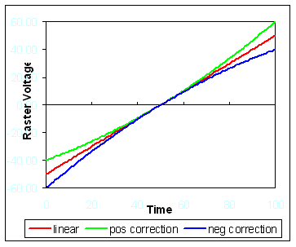

The linearity compensation is achieved by the means of 2 coefficients A1x and A1y. Along a frame, the deflection voltages, respectively X and Y, are proportional to

*Xi = 3\*i +½ \* A1x\*(i/1024)2*

*Yj = 3\*j +½ \* A1y\*(j/1024)2*

*i* is incremented from *-511* to *512* during the line rastering and *j* is incremented from *-511* to *512* during the frame rastering.

The hereunder [*Raster parameter dataflow sketch*](#Raster_sketch) allows to understand how this non-linearity correction is produced

**Raster parameter dataflow sketch**

**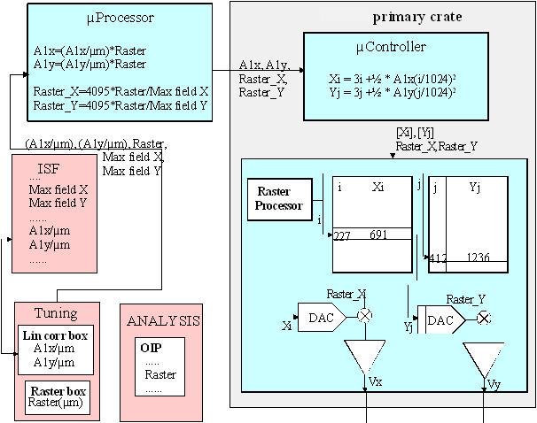**

In the above sketch, it can be seen that, from the A1x and A1y coefficients, the µController computes a set of 1024 coefficients Xi or Yj which are stored in a register further addressed by the *Raster Processor*. The generation of 2x1024 coefficients requires 1 to 2 seconds.

**For given physical conditions, the linearity correction loaded in the hardware depends on the *Raster size***

The linearity correction resulting from a pair of coefficients (A1x, A1y) generates the same relative distortion for any raster field, while the physical distortion which is targeted to be corrected is just a function of the absolute deflection.

Consequently, for a given set of coefficients (*[Xi]*, *[Yj]*), the distortion correction is only valid for a single raster field. The *[Xi]* and *[Yj]* tables should be updated at every *Raster* change. See in the next paragraph the rules governing this updating.

**The linearity correction main features are**

* In the *Tuning* "linearity correction box", the user may enter crater bottom measurement data which will be converted by the program into *A1/µm* (i.e. *A1x*/*Raster* or *A1y*/*Raster*.)
* This pair of coefficients are stored in the ISF
* The registers *[Xi] [Yj]* are updated with the current *Raster* when closing the *linearity box* with *Apply*.
* The registers *[Xi] [Yj]* are updated before every analysis, according to the raster size applied by the *OIP loading* occuring at the beginning of ecery analysis.
* The registers *[Xi] [Yj]* are not updated when changing the *Raster* size in the *Tuning*.

[Contents ↑](#Contents)

#### The Raster linearity correction box

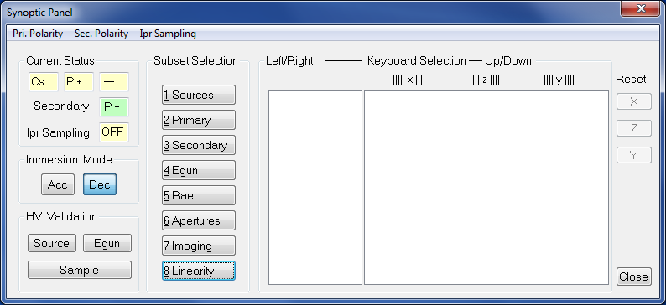

For opening the *Raster linearity correction box* open first the *synoptic* box and click the last button *linearity.*

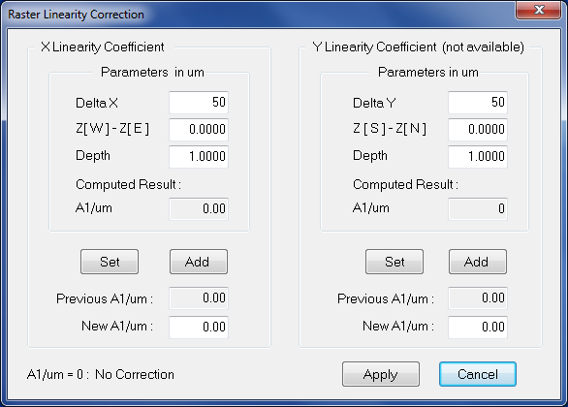

* **Delta X**, **Delta Y**, **Z(W)-Z(E)**, **Z(S)-Z(N)**, **Depth** are editing fields. The values are derived from the measurement of craters, for example with a surface profilometer. See the hereunder [crater sketch](#crater).
* **A1/µm** displays the result computed by the program according to the formulas



* **Set** button fills the *New A1/µm* field with the *Computed A1/µm*
* **Add** button fills the *New A1/µm* field with the sum of *Computed A1µm* and *Previous A1/µm*. This is suited when the measured crater profile has been made with the *Previous A1/µm*.
* **Previous A1/µm** displays the current *A1/µm*
* **Apply** closes the box with updating *A1/µm* with the *New A1/µm*. This new *A1/µm* will be stored in the ISF at the next save or save as operation. It also updates the actual correction (computing and loading the [Xi] [Yj] tables) taking into account the current *Raster*.
* **Cancel** closes the box without modifying anything

The labels for *A1x/µm* and *A1y/µm* in the ISF are respectively: DD\_VPAR\_RASTER\_M\_NFX\_#2061

DD\_VPAR\_RASTER\_M\_NFY\_#2062

**crater sketch**



This sketch stands for the X axis case. For the Y axis case, replace respectively X, W en E by Y, S and N.

**Example**: The Raster Field is 150 µm; a profilometer measurement gives a crater bottom slope of 0.04µm/50µm for a crater depth of 2µm. Thus, NF=4 10-4 µm-1. Thus A1 must be set to 184.

[Contents ↑](#Contents)

## The indexation reference guide

### Valid + Source Accel HV

(X means a linear update)

**ISF Parameters available from the kbd thumbwheel**

|  |  |  |
| --- | --- | --- |
| **Parameters** | **Tuning Label** | **Updating** |
| Source HV | Source HV | - |
| Primary Deflector 1 X | DP 1 X | X |
| Primary Deflector 1 Y | DP 1 Y | X |
| Primary Wien Deflector X | DP WL X | X |
| Primary Wien Deflector Y | DP WL Y | X |
| Wien filter Plate Y | WIEN DY | Square Root |
| Wien filter Coil | WIEN COIL | Square Root |
| Primary Deflector 3a X | DP 3a X | X |
| Primary Deflector 3a Y | DP 3a Y | X |
| Primary Deflector 3b X | DP 3b X | X |
| Primary Deflector 3b Y | DP 3b Y | X |
| Primary Deflector 4 X | DP 4 X | X |
| Primary Deflector 4 Y | DP 4 Y | X |
| Primary Stig 45 deg | STIG 45 | X |
| Primary Stig 90 deg | STIG 90 | X |
| Primary Beam position X | BEAM POS X | X |
| Primary Beam position Y | BEAM POS Y | X |
| Primary Lens 1 | L1 | X |
| Primary Lens 2 | L2 | X |
| Primary Lens 3 | L3 | X |
| Primary Lens 4 | L4 | X |
| Primary Wien Lens | WIEN LENS | X |
| Primary Raster X | RASTER X | X |
| Primary Raster Y | RASTER Y | X |
| Primary Faraday Cup Deflector | DEF FC | X |
| Prim. Aperture D0 X | D0 X | No |
| Prim. Aperture D0 Y | D0 Y | No |
| Prim. Aperture D4 X | D4 X | No |
| Prim. Aperture D4 Y | D4 Y | No |
| Duo Accel | Duo ACL | No |

**ISF parameters not available from the kbd thumbwheels**

|  |  |
| --- | --- |
| **Parameters** | **Updating** |
| Normal Source HV | - |
| maximum field x | 1/(Source Accel) |
| maximum field y | 1/(Source Accel) |
| Primary source polarity | No |

### Valid + Sample HV

(X means a linear update)

Only the kbd available ISF parameters are updated by *VALID + Sample HV*

| **Parameters** | **Tuning Label** | **Updating** |
| --- | --- | --- |
| Sample HV | Sample HV | - |
| Immersion lens | LIMM | X |
| Transfer Def X | DT FA X | X |
| Transfer Def Y | DT FA Y | X |
| Transfer Stigmator X | STIG X | X |
| Transfer Stigmator Y | STIG Y | X |
| Transfer Lens 1 | LTR 1 | X |
| Transfer Lens 2 | LTR 2 | X |
| Contrast Aperture X | CA X | No |
| Contrast Aperture Y | CA Y | No |
| Entrance slit X | ENT SL X | No |
| Entrance slit W | ENT SL W | No |
| Field Aperture X | FA X | No |
| Field Aperture Y | FA Y | No |
| Main ESA X | ESA | X |
| Spectrometer Lens | LCOUP | X |
| Projection Def X | DPR X | X |
| Projection Def Y | DPR Y | X |
| Projection Slit/Image Stig XY | STIG XY | X |
| Project. Slit/Image Quadrupole | QUAD | X |
| Dynamic transfer X | DT RASTER X | X |
| Dynamic transfer Y | DT RASTER Y | X |
| Dynamic transfer rotation X | DT ROT X | No |
| Dynamic transfer rotation Y | DT ROT Y | No |
| EM Gate width W | E.GATE W | No |
| Projection Lens 1 | LPR 1 | X |
| Projection Lens 2 | LPR 2 | X |
| Exit ESA | ESA EXIT | X |
| Switch EM Def Y | DEM | X |
| Switch FC Def Y | DFC | X |
| EM Post acceler. Voltage | EM PAHV | No |
| Projection last Def X | D MCP X | X |
| Projection last Def Y | D MCP Y | X |
| Energy slit position X | ENRG SL X | No |
| Energy slit width W | ENRG SL W | No |
| Exit slit width W | EXT SL | No |

[Contents ↑](#Contents)